NORTH ROAD FLORALS

Relational Database

Designed by Kathy Coomes

For

Database Management – Alan Labouseur

Spring 2017 – due 05/02/2017

**Table of Contents**

……………………………………………………………………………………………………………………………………………

Summary 4

…………………………………………………………………………………………………………………………………………………………………………………………..

Entity Relationship Diagram 5

…………………………………………………………………………………………………………………………………………………………………………………………..

Types: phone, prod, pos 6

…………………………………………………………………………………………………………………………………………………………………………………………..

Tables

People table 7

Vendors table 8

VendorContacts table 9

Staff table 10

Customers table 11

Addresses table 12

Products table 13

ProductHistory table 14

Arrangements table 15

ArrangementItems 16

ArrangementItemsList 17

Inventory table 18

Orders table 19

……………………………………………………………………………………………………………………………………………………………………………………………

Stored Procedures (also see Triggers)

GetArrListofItems 20

GetProductOrderList 21

AddPeople 22 - 24

AddVendors (also see Reports) 25

AddProducts (also see Reports) 26 – 27

FindAlan (created by Daniel Verite – shared on Stack Overflow) 28 - 29

……………………………………………………………………………………………………………………………………………………………………………………………

Triggers

ValidPeopleInput with Stored Procedure ValidatePeopleInput() 30

ValidVendorInput with Stored Procedure ValidateVendorInput() 31

……………………………………………………………………………………………………………………………………………………………………………………………

**Table of Contents**

Views – (each with their own reports)

VendorInfo 32

Select all

Find vendor name by entering something LIKE the name

StaffInfo 33 - 34

Select all

Find an employee by entering something LIKE the first name

List all current Staff of North Road Florals

List any staff that has left North Road Florals

CustomerInfo 35

Select all

Find all Customers by entering something LIKE a city

ProductInfo 36 - 37

Select all

List current and history costs of Products bought

…………………………………………………………………………………………………………………………………………………………………………………………………..

Reports

To list everything included in every table 38

Arrangement Item List 38

Vendors with no Vendor Contact 38

Vendors with no Products 39

Vendor from which we order the most 40

Find a Vendor city 40

Examples for reports from Stored Procedure AddVendors 41

Examples for reports from Stored Procedure AddProducts 41

…………………………………………………………………………………………………………………………………………………………………………………………………..

Roles and Security 42

…………………………………………………………………………………………………………………………………………………………………………………………………..

Implementation Notes 43

…………………………………………………………………………………………………………………………………………………………………………………………….……

Known Problems and Future Enhancements 44

…………………………………………………………………………………………………………………………………………………………………………………………………..

**Summary**

North Road Florals is a large floral business that has been steadily growing. The company has found that using spreadsheets, as they have, is no longer the most accurate, fastest and easiest way to handle all the information it needs to track about the people involved in or with the company – (Staff, Customers, and Vendor Contacts along with all their information). I was contacted to create a relational database for the company. They also wanted to track the history of products bought - including the current and past history of prices. Having spoken with the owner, arrangers, manager, and sales clerks many times, I have designed such a database in PostgreSQL.

While speaking with the staff of the company, I found that they also wanted the ability when an arrangement was ordered to check the list of items needed for that arrangement against inventory giving them a list of products needed to be ordered. I was able to create a stored procedure for them where all they need do is to enter the arrangement ID and they will receive a list of products to order.

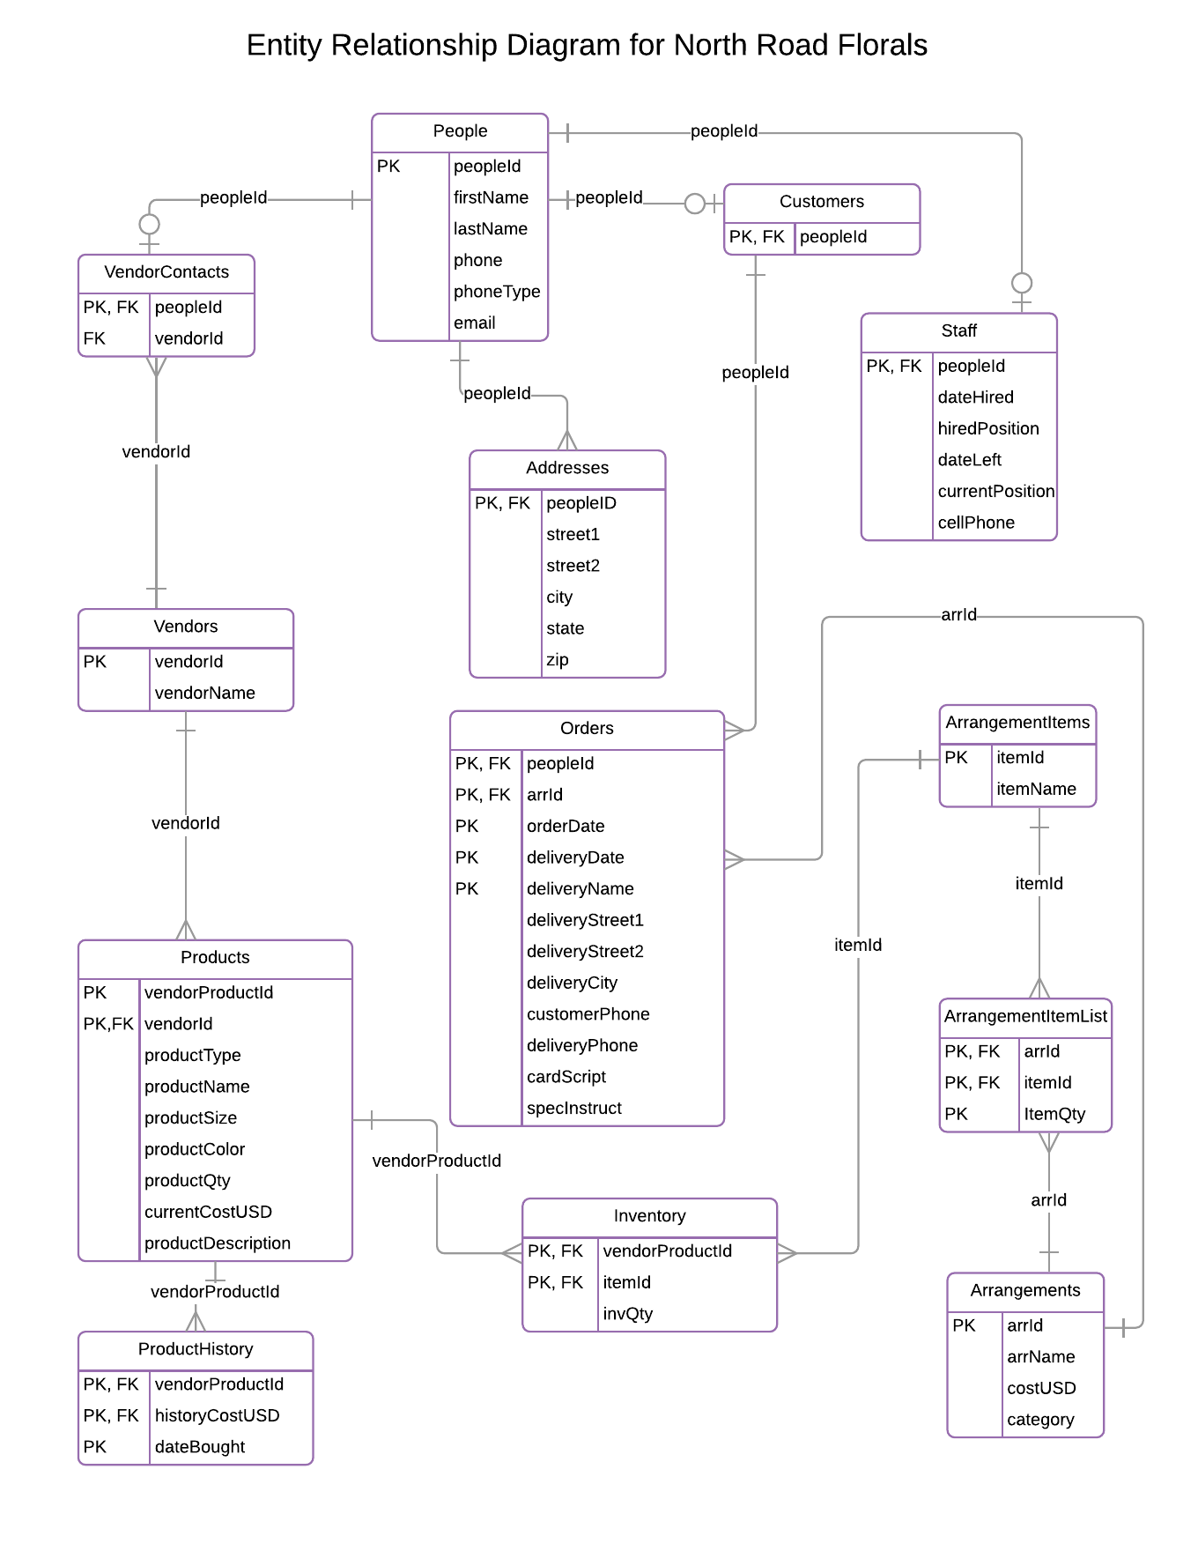

**Types**

**phone Type** - the phone type is used in the People table

CREATE TYPE phone as ENUM ('work', 'home', 'cell');

-- -----------------------------------------------------------------------

**product Type** - used in the Product Table

CREATE TYPE prod as ENUM ('flower', 'container', 'greenery', 'balloon', 'other');

-- -----------------------------------------------------------------------

**position TYPE** - used in the Staff Table for hiredPosition and position

CREATE TYPE pos as ENUM ('owner', 'arranger', 'manager', 'salesclerk');

**Tables**

-- -----------------------------------------------------------------------

**People**

This table keeps track of the basic information that VendorContacts,

Customers and Staff have in common.

-- -----------------------------------------------------------------------

CREATE TABLE People(

peopleId text not null unique,

firstName text not null,

lastName text not null,

phone text,

phoneType text,

email text,

primary key(peopleId)

);

**Functional Dependencies**:

peopleId 🡪firstName, lastName, phone, phoneType, email

**Sample Data:**

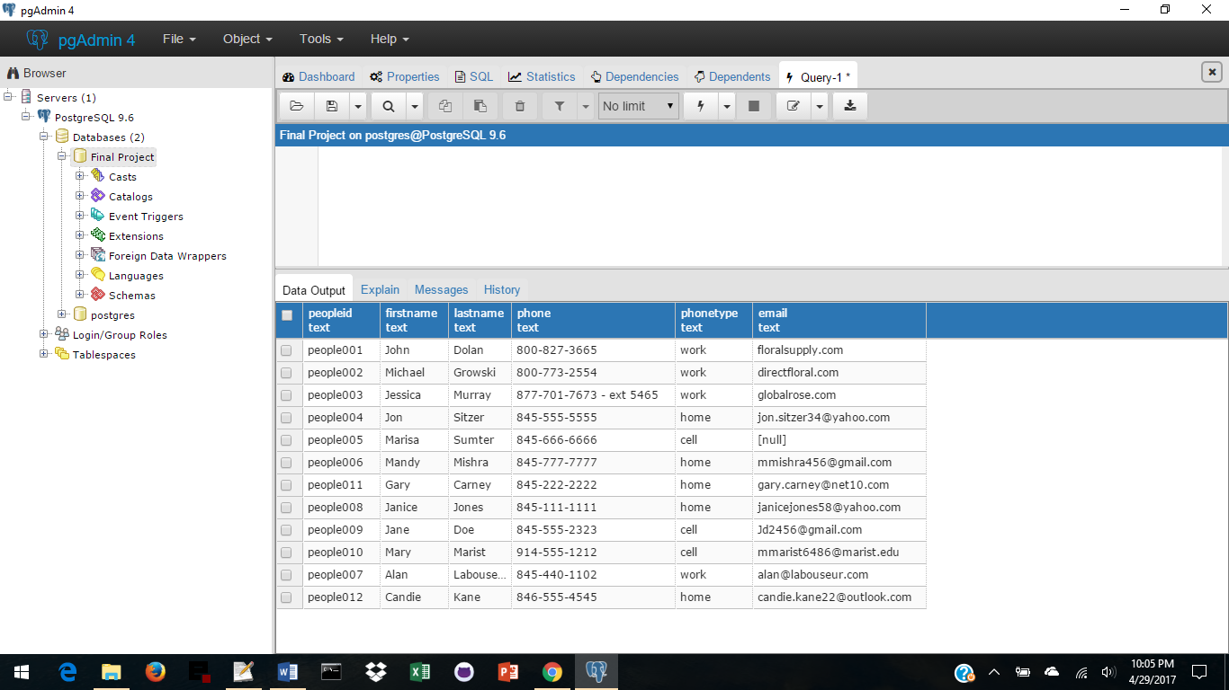

**Tables**

-- -----------------------------------------------------------------------

**Vendors**

This table tracks Vendors from which the company buys its products.

It creates a many to many relationship between VendorContacts and Products.

-- -----------------------------------------------------------------------

CREATE TABLE Vendors(

vendorId text not null unique,

vendorName text not null,

primary key(vendorId)

);

**Functional Dependencies**:

vendorId 🡪 vendorName

**Sample Data:**

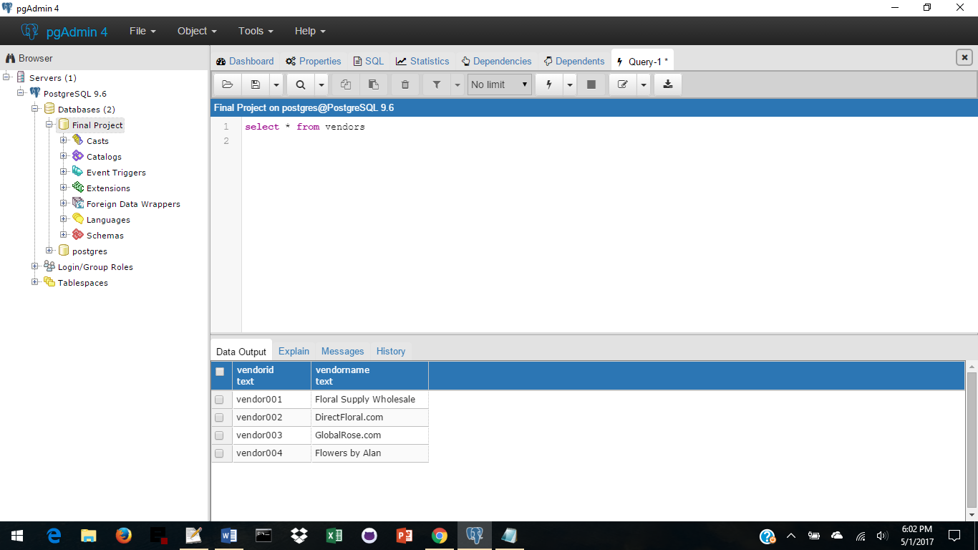

**Tables**

-- -----------------------------------------------------------------------

**VendorContacts**

This table is an extension of the People table for Vendor Contact Information.

-- -----------------------------------------------------------------------

CREATE TABLE VendorContacts (

peopleId text not null references People(peopleId),

vendorId text not null references Vendors(vendorId),

primary key(peopleId, vendorId)

);

**Functional Dependencies**:

peopleId 🡪 vendorId

**Sample Data:**

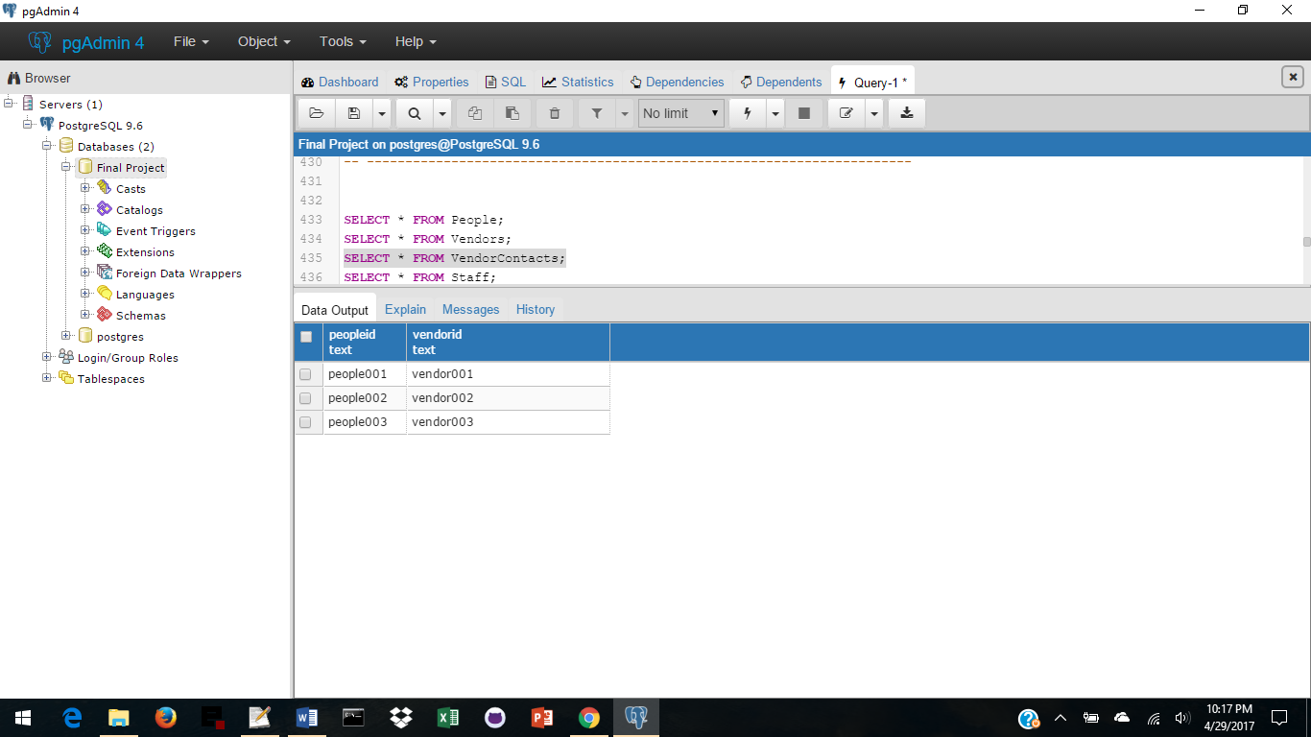

**Tables**

-- -----------------------------------------------------------------------

**Staff**

This table is an extension of the People table for Staff Information.

-- -----------------------------------------------------------------------

CREATE TABLE Staff (

peopleId text not null references People(peopleId),

dateHired text not null,

hiredPosition pos not null,

dateLeft text DEFAULT NULL,

position pos not null,

cellPhone text,

primary key(peopleId)

);

**Functional Dependencies**:

peopleId 🡪dateHired, hiredPosition, dateLeft, position, cellphone

**Sample Data:**

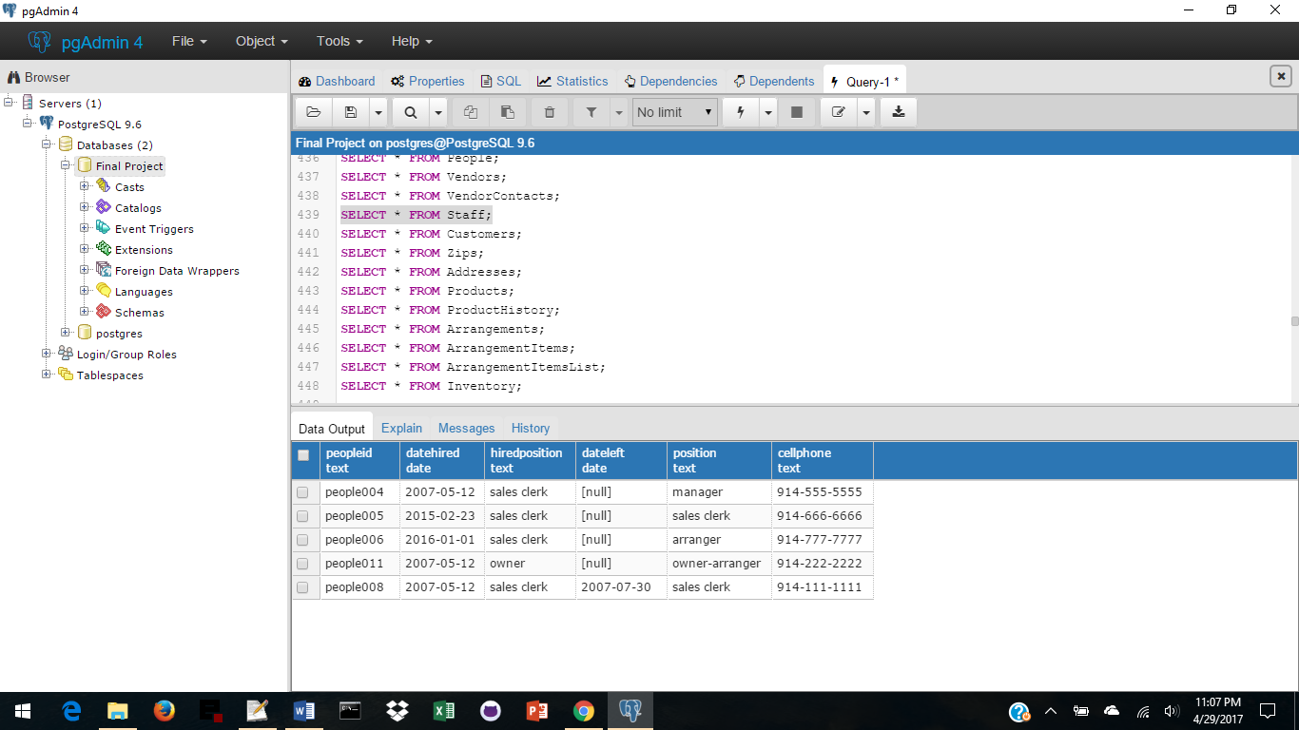

**Tables**

-- -----------------------------------------------------------------------

**Customers**

This table is an extension of the People Table for Customer Information.

-- -----------------------------------------------------------------------

CREATE TABLE Customers (

peopleId text not null references People(peopleId),

primary key(peopleId)

);

**Functional Dependencies**:

peopleId

**Sample Data:**

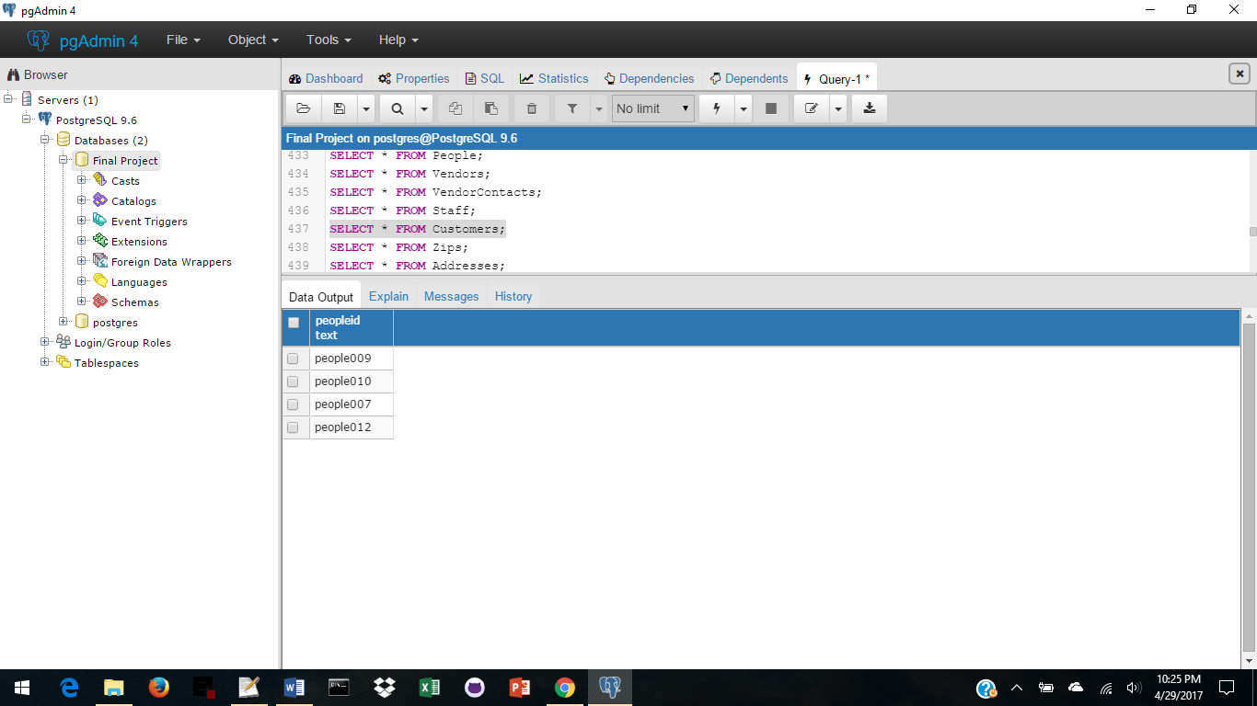

**Tables**

-- -----------------------------------------------------------------------

**Addresses**

This table keeps track of the addresses of all People.

-- -----------------------------------------------------------------------

CREATE TABLE Addresses (

peopleId text not null references People(peopleId),

street1 text,

street2 text,

zip text not null references Zips(zip),

primary key(peopleId)

);

**Functional Dependencies**:

peopleId 🡪 street1, street2, zip

**Sample Data:**

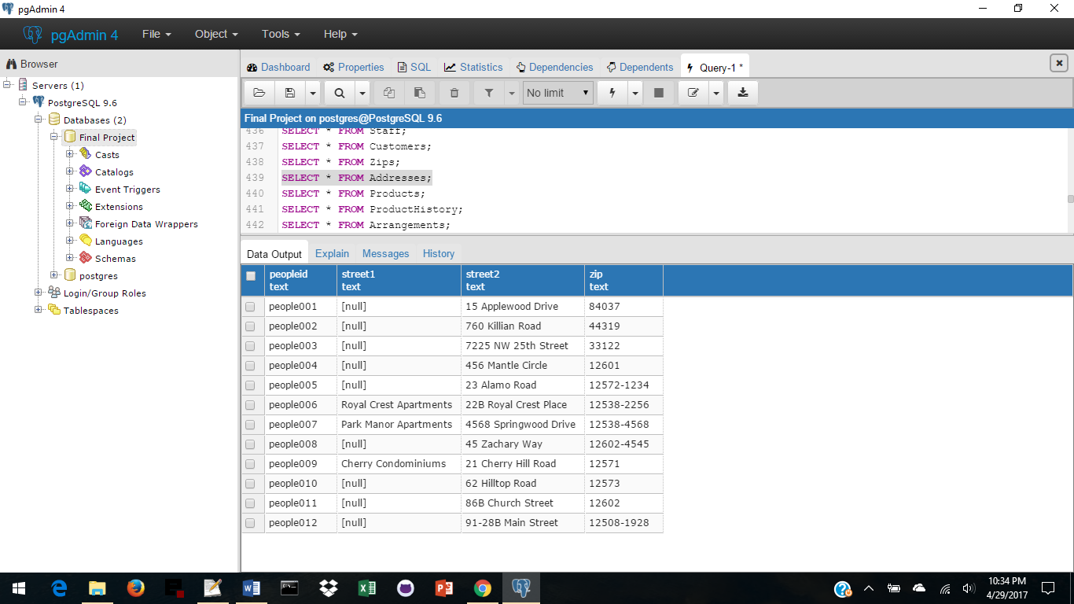

**Tables**

-- -----------------------------------------------------------------------

**Products**

This table tracks current product information.

-- -----------------------------------------------------------------------

CREATE TABLE Products (

vendorProductId text not null unique,

vendorId text not null references Vendors(vendorId),

productType prod,

productName text,

productSize text,

productColor text,

productQty int CHECK (productQty >= 0),

-- # of items in currentCostUSD, might be sold singly, or by the dozen

currentCostUSD numeric(6,2) CHECK (currentCostUSD > 0),

productDesc text,

primary key(vendorProductId, vendorId)

);

**Functional Dependencies**:

vendorProductId, vendorID 🡪 productType, productName, productSize, productColor,

productQty, currentCostUSD, productDesc

**Sample Data:**

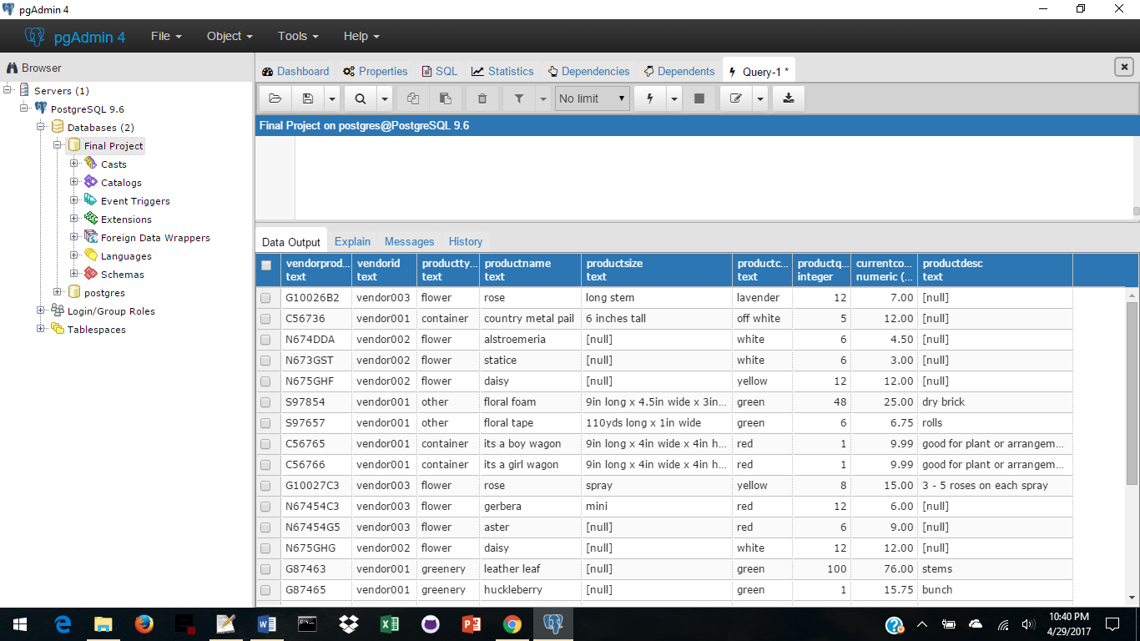

**Tables**

-- -----------------------------------------------------------------------

**ProductHistory**

This table tracks the history of products: ID, cost when bought, date bought.

-- -----------------------------------------------------------------------

CREATE TABLE ProductHistory (

vendorProductId text references Products(vendorProductId),

historyCostUSD numeric(6,2) not null CHECK (historyCostUSD > 0),

dateBought text not null,

primary key(vendorProductId, historyCostUSD, dateBought)

);

**Functional Dependencies**:

vendorProductId 🡪 historyCostUSD, dateBought

**Sample Data:**

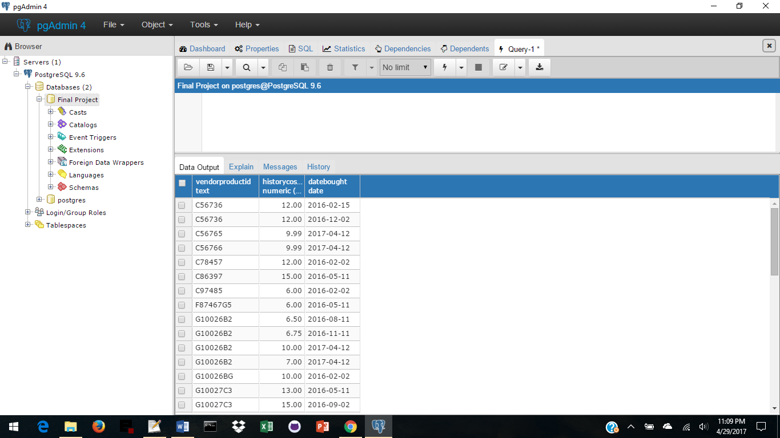

**Tables**

-- -----------------------------------------------------------------------

**Arrangements**

This table tracks arrangements: ID, name, cost, and category.

Category can be any holiday, birthday, birth of a child, thank you, etc.

-- -----------------------------------------------------------------------

CREATE TABLE Arrangements(

arrId text not null unique,

arrName text not null,

arrCostUSD numeric (6,2) not null CHECK (arrCostUSD > 0),

category text not null,

primary key(arrId)

);

**Functional Dependencies**:

arid 🡪arrName, arrCostUSD, category

**Sample Data:**

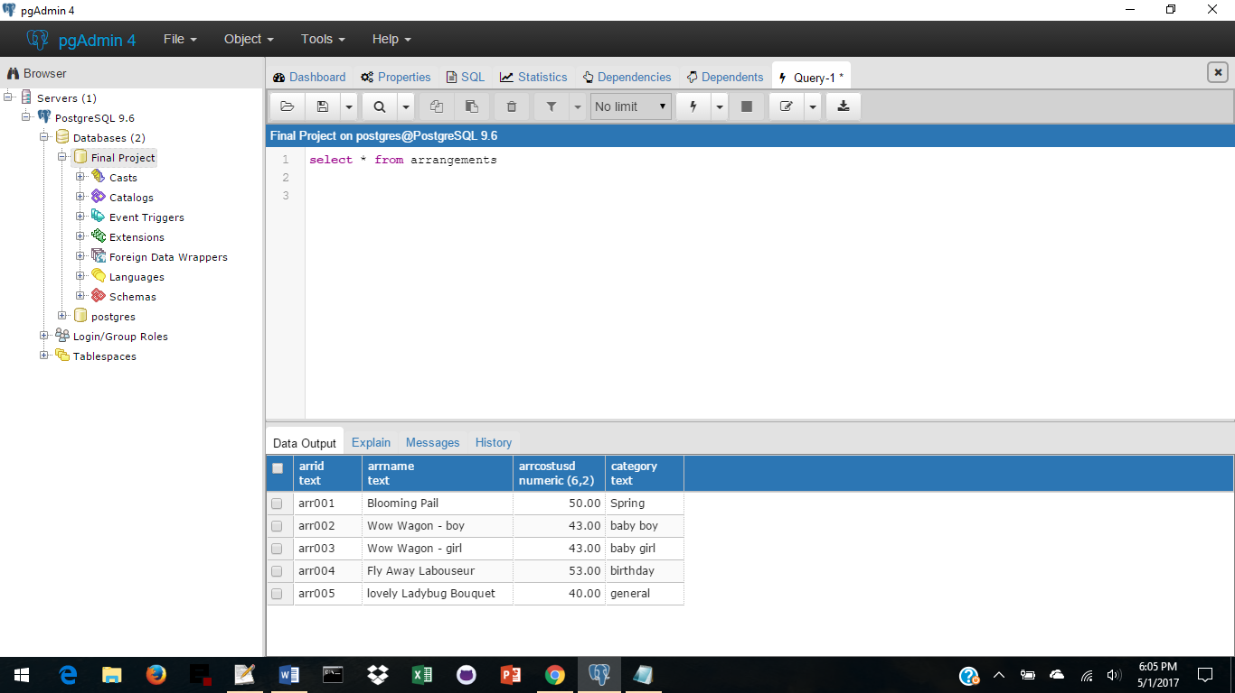

**Tables**

-- -----------------------------------------------------------------------

**ArrangementItems**

This table gives a list of items that can be used in an arrangement.

-- -----------------------------------------------------------------------

CREATE TABLE ArrangementItems(

itemId text not null unique,

itemName text not null,

primary key(itemId)

);

**Functional Dependencies**:

itemId 🡪 itemName

**Sample Data:**

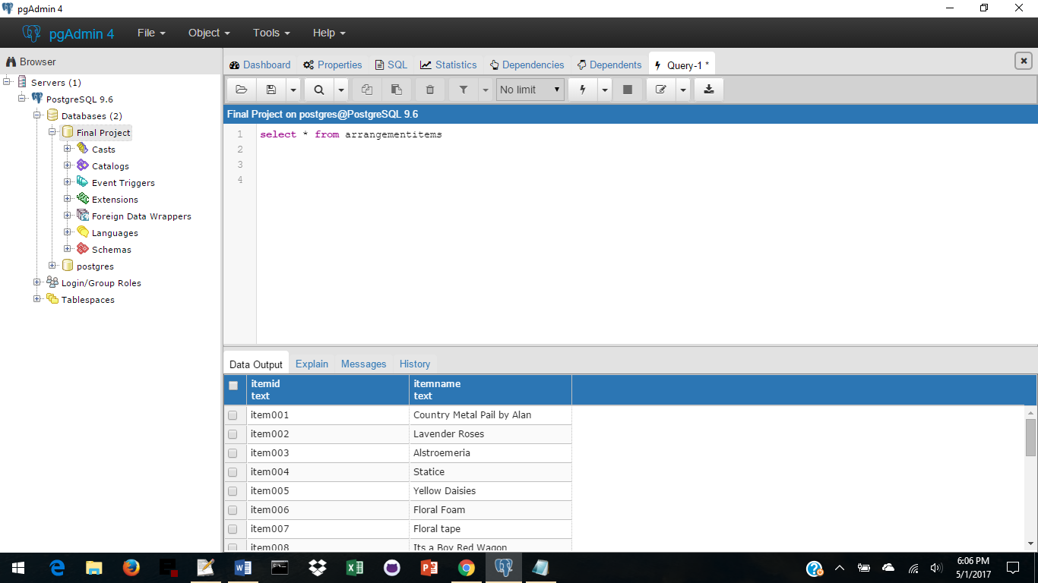

**Tables**

-- -----------------------------------------------------------------------

**ArrangementItemsList**

This table brings together the arrangement and arrangementItems tables

giving the number of each item to be used in each arrangement.

-- -----------------------------------------------------------------------

CREATE TABLE ArrangementItemsList(

arrId text not null references Arrangements(arrId),

itemId text not null references ArrangementItems(itemId),

itemQty int not null CHECK (itemQty >= 0) ,

primary key(arrId, itemId, itemQty)

);

**Functional Dependencies**:

arrId, itemId 🡪 itemQty

**Sample Data:**

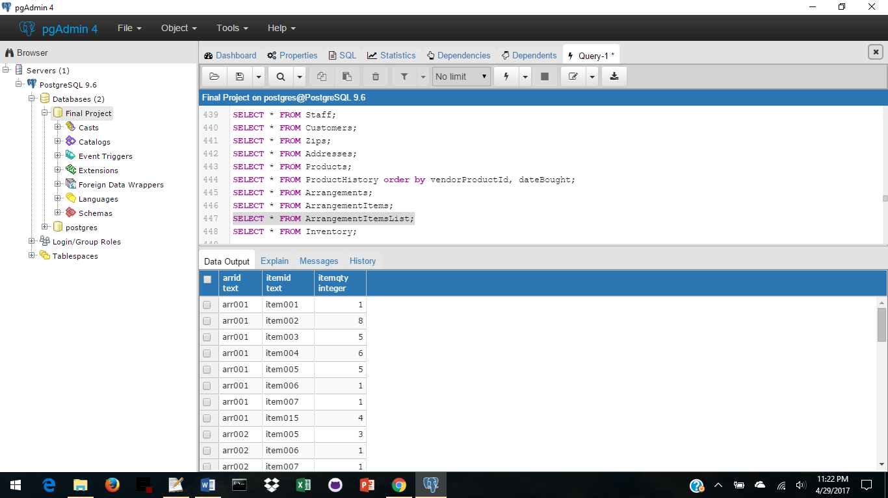

**Tables**

-- -----------------------------------------------------------------------

**Inventory**

This table is a list of how many of each item the company has on hand.

It creates a many to many relationship between Products and ArrangementItems.

-- -----------------------------------------------------------------------

CREATE TABLE Inventory (

vendorProductId text references Products(vendorProductId),

itemId text references ArrangementItems(itemId),

invQty int CHECK (invQty >= 0) ,

primary key(vendorProductId, itemId)

);

**Functional Dependencies**:

vendorProductId, itemId 🡪 invQty

**Sample Data:**

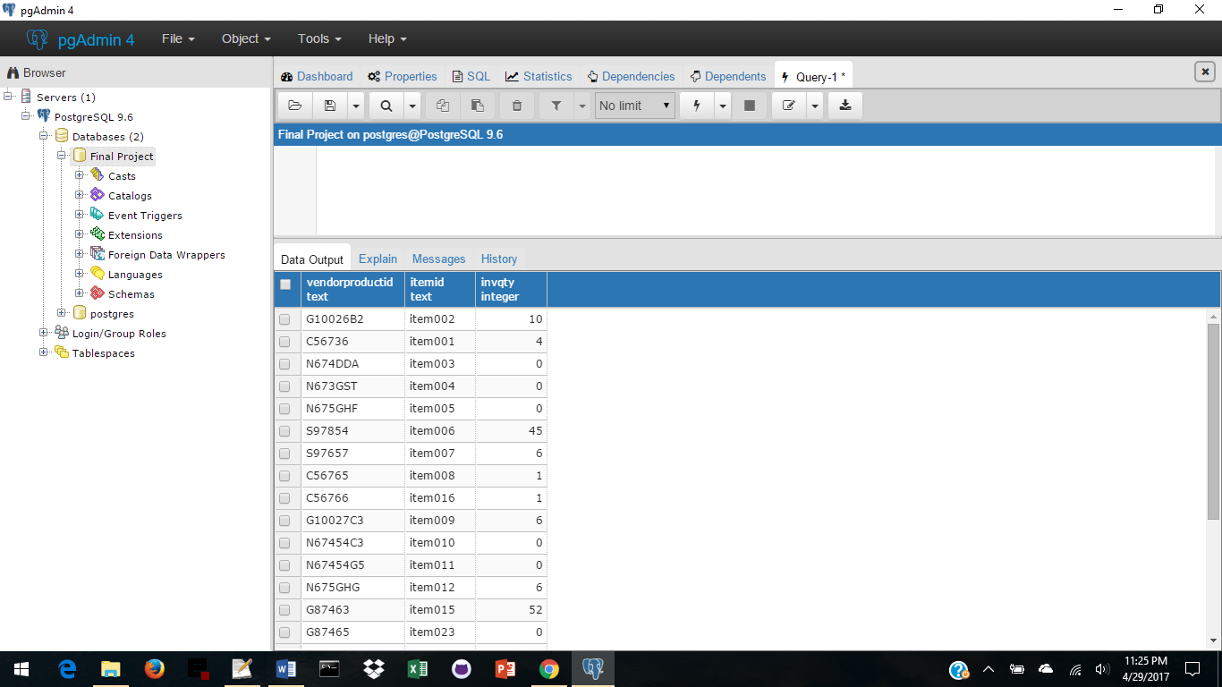

**Tables**

-- -----------------------------------------------------------------------

**Orders**

This table is a list of orders of arrangements from the Customer.

It creates a many to many relationship from Customers to Arrangements.

-- -----------------------------------------------------------------------

CREATE TABLE Orders (

peopleId text references People(peopleId),

arrId text references Arrangements(arrId),

orderDate date CHECK (orderDate <= deliveryDate),

deliveryDate date CHECK (deliveryDate >= orderDate),

deliveryName text,

deliveryStreet1 text,

deliveryStreet2 text,

deliveryCity text,

customerPhone text,

deliveryPhone text,

cardScript text not null, -- what to write on card

specInstruct text not null DEFAULT 'none', -- special instructions for delivery

primary key(peopleId, arrId, orderDate, deliveryDate, deliveryName)

);

**Functional Dependencies**:

peopleId, arrId, orderDate, deliveryDate, deliveryName 🡪 🡪 deliveryStreet1, deliveryStreet2,

deliveryCity, customerPhone, deliveryPhone, cardScript, specInstruct

Sample Data:

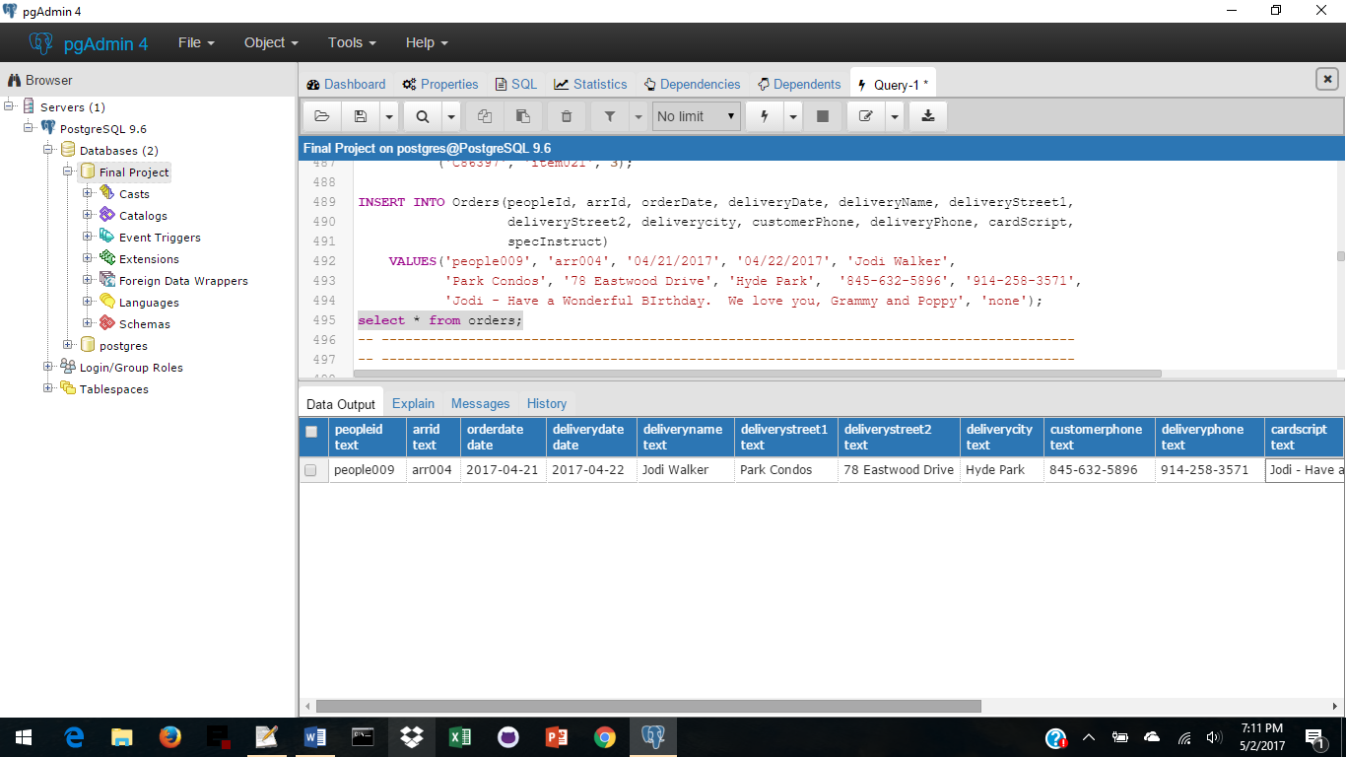

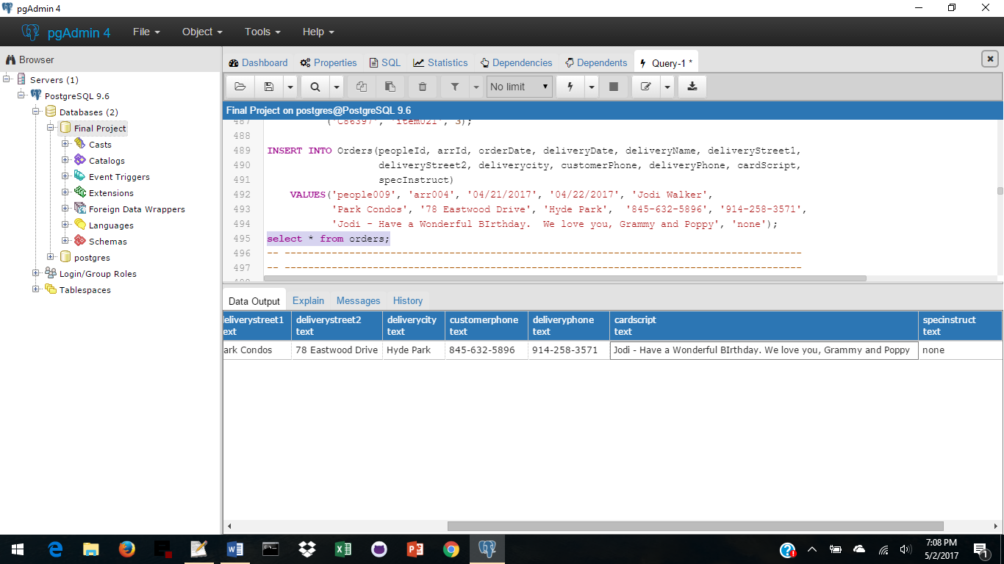

**Stored Procedures**

-- -----------------------------------------------------------------------

**GetArrListofItems** - Stored Procedure - enter arrId

To obtain a list of items and quantities of each for that arrangement

-- -----------------------------------------------------------------------

CREATE OR REPLACE FUNCTION GetArrListofItems(TEXT, REFCURSOR)

RETURNS refcursor AS

$$

DECLARE

arrIdEntered TEXT := $1;

resultset REFCURSOR := $2;

BEGIN

OPEN resultset FOR

SELECT a.arrId, p.itemId, p.itemName, apl.itemQty

FROM Arrangements a INNER JOIN ArrangementItemsList apl ON a.arrId = apl.arrId

INNER JOIN ArrangementItems p ON apl.itemId = p.itemId

WHERE a.arrId = arrIdEntered

ORDER BY p.itemId ASC;

RETURN resultset;

END;

$$

LANGUAGE plpgsql;

SELECT GetArrListofItems('arr002', 'results');

FETCH all FROM results;

**Sample Data:**

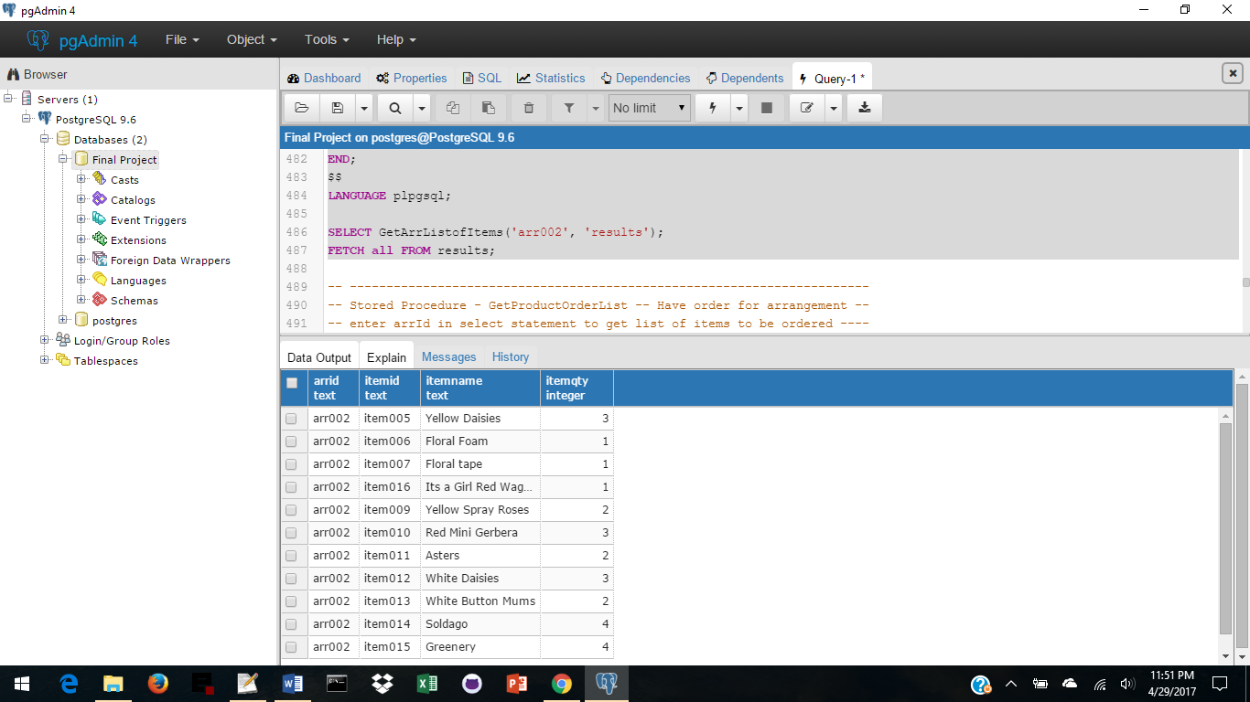

**Stored Procedures**

-- -----------------------------------------------------------------------

**GetProductOrderList**

A customer has ordered an arrangement - Enter the arrId and this stored procedure compares the items needed for the arrangement against what is in Inventory and gives a list of items that need to be ordered.

-- -----------------------------------------------------------------------

CREATE OR REPLACE FUNCTION GetProductOrderLIst(TEXT, REFCURSOR) RETURNS refcursor AS

$$

DECLARE

arrIdEntered TEXT := $1;

resultset REFCURSOR := $2;

BEGIN

OPEN resultset FOR

SELECT i.itemId, i.vendorProductID, v.vendorName, pe.firstName, pe.lastName,

pe.phone

FROM Inventory i INNER JOIN ArrangementItems ai ON i.itemId = ai.itemId

INNER JOIN ArrangementItemsList ail ON ail.itemId = ai.itemId

INNER JOIN Arrangements a ON ail.arrId = a.arrId

INNER JOIN Products pr ON i.vendorProductId = pr.vendorProductId

INNER JOIN Vendors v ON pr.vendorID = v.vendorId

INNER JOIN VendorContacts vc ON v.vendorId = vc.vendorId

INNER JOIN People pe ON vc.peopleId = pe.peopleId

WHERE a.arrId = arrIdEntered and i.invQty <= ail.itemQty

ORDER BY p.itemId ASC;

RETURN resultset;

END;

$$

LANGUAGE plpgsql;

SELECT GetProductOrderList('arr002', 'results2');

FETCH all FROM results2;

**Sample Data:**

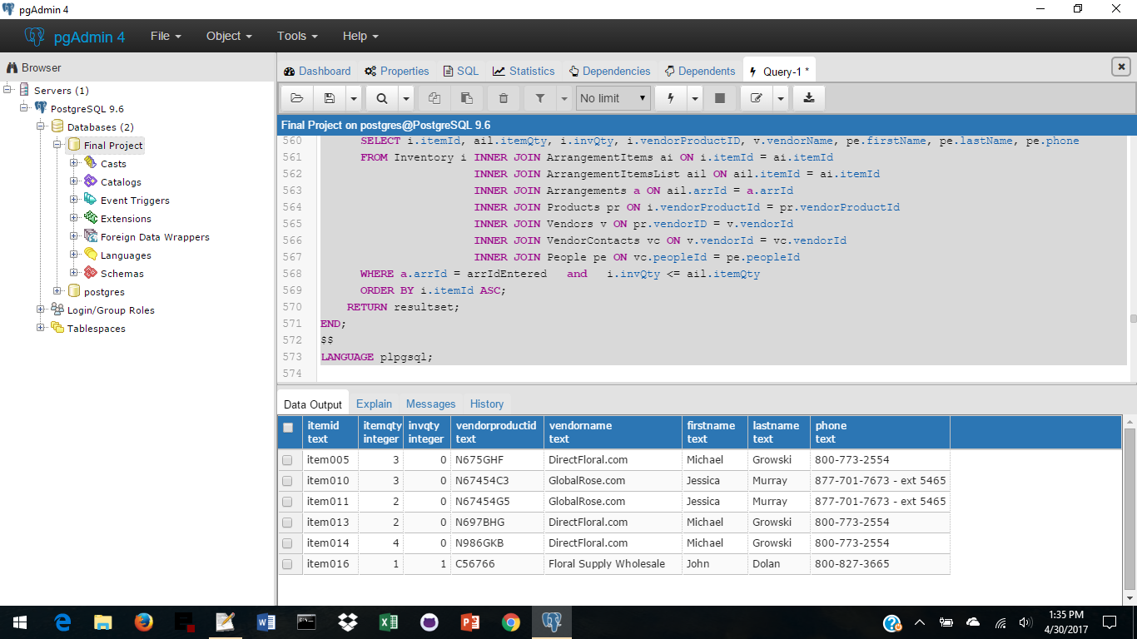

**Stored Procedures**

-- -----------------------------------------------------------------------

**AddPeople -**

select addPeople(enter info with NULL for data not needed);

procedure then adds people and address information, and uses IF statements to decide

whether to enter Staff or Customer or VendorContact information

-- -----------------------------------------------------------------------

CREATE OR REPLACE FUNCTION AddPeople

(peopleType text, peopleId text, firstName text, lastName text, phone text,

phoneType phone, email text, street1 text, street2 text, city text, state text,

zip text, dateHired date, hiredPosition pos, dateLeft date, currentPosition pos,

cellPhone text, vendorId text)

RETURNS void AS

$$

BEGIN

INSERT INTO People

VALUES (peopleId, firstName, lastName, phone, phoneType, email);

INSERT INTO addresses

VALUES(peopleId, street1, street2, city, state, zip);

IF peopleType = 'S' THEN

INSERT INTO Staff

VALUES(peopleId, dateHired, hiredPosition, dateLeft, currentPosition,

cellPhone);

END IF;

IF peopleType = 'C' THEN

INSERT INTO Customers

VALUES(peopleId);

END IF;

IF peopleType = 'V' THEN

INSERT INTO VendorContacts

VALUES(peopleId, vendorId);

END IF;

END

$$

LANGUAGE plpgsql;

-- TEST DATA for AddPeople - Staff:

Select AddPeople('S','people013', 'Kathy', 'Coomes', '555-555-5555', 'cell',

'kathy.coomes@marist.edu', NULL, '19 Church Street', 'Red Hook', 'New York', '12571',

'04/30/2017', 'arranger', NULL, 'arranger', '555-555-5555', NULL);

select * from StaffInfo;

**Stored Procedures**

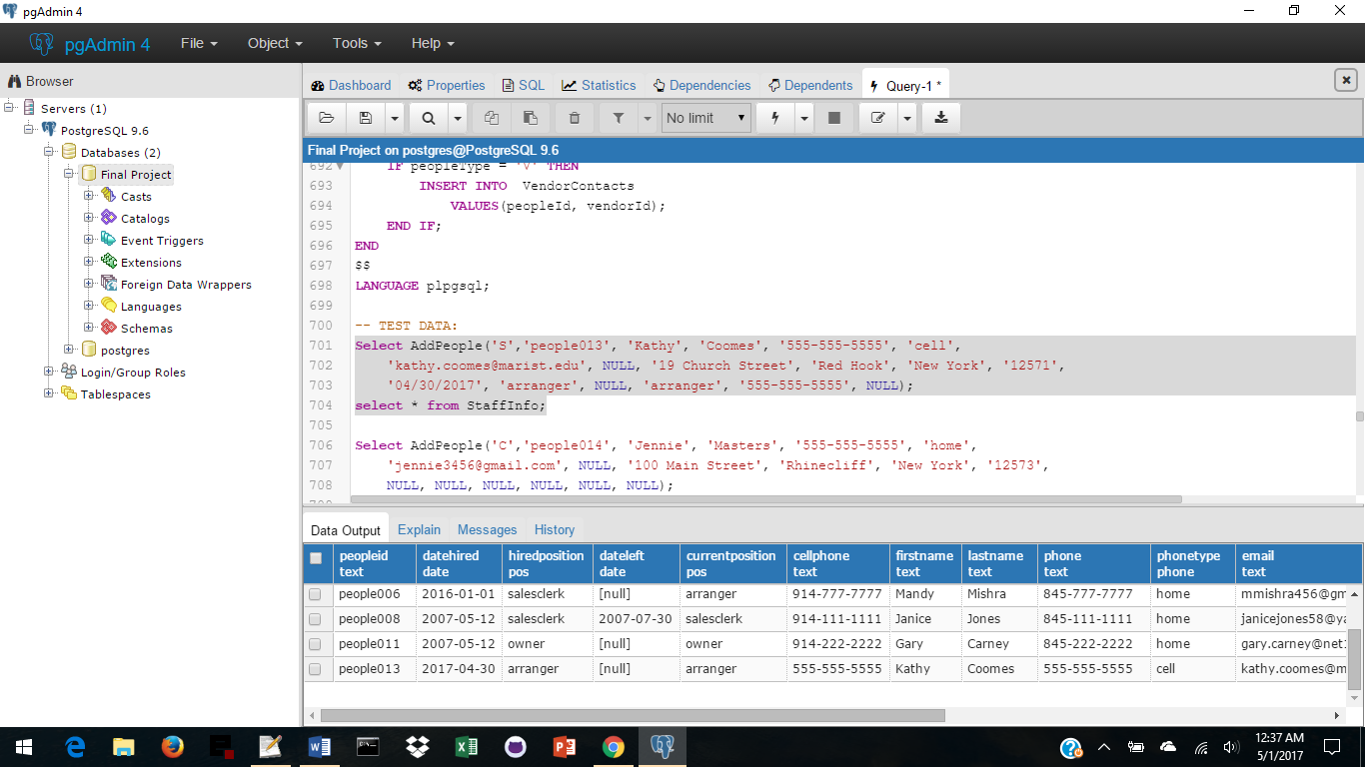

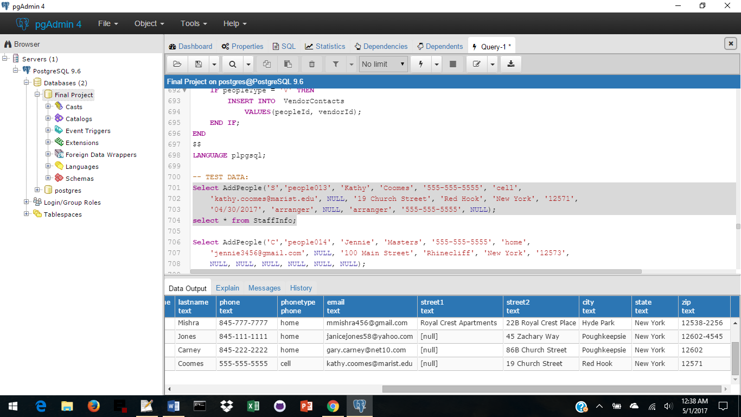

-- TEST DATA for AddPeople - Customers:

Select AddPeople('C','people014', 'Jennie', 'Masters', '555-555-5555', 'home',

'jennie3456@gmail.com', NULL, '100 Main Street', 'Rhinecliff', 'New York', '12573',

NULL, NULL, NULL, NULL, NULL, NULL);

SELECT * FROM CustomerInfo;

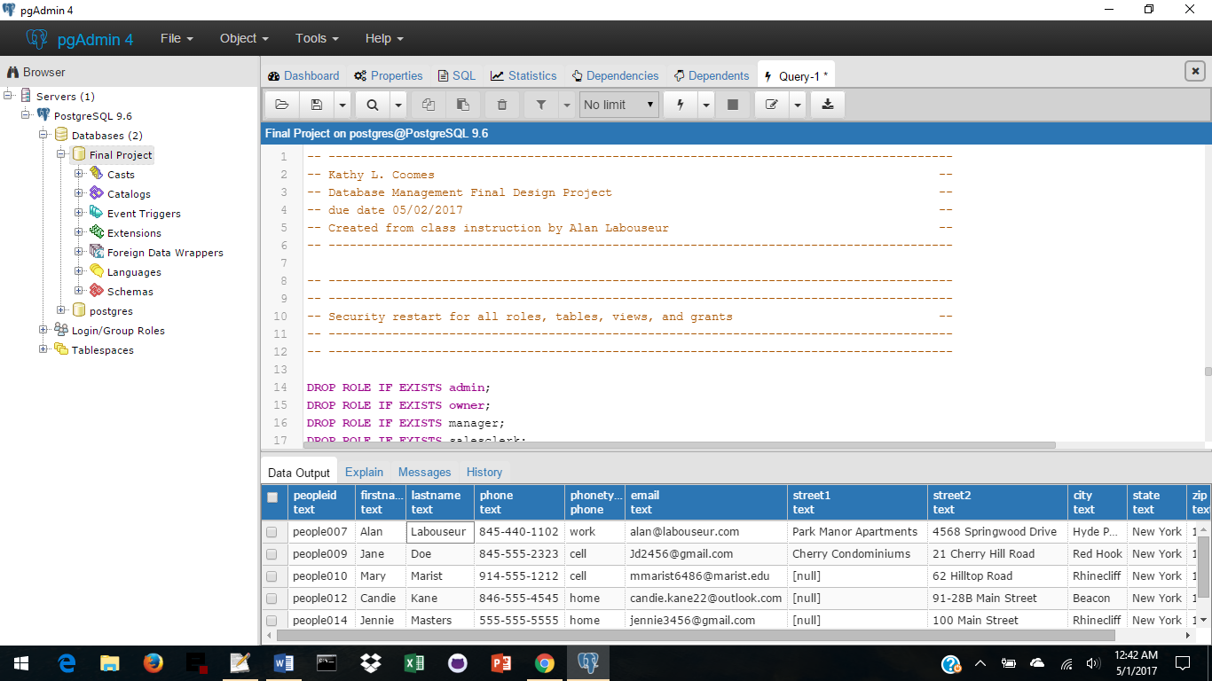

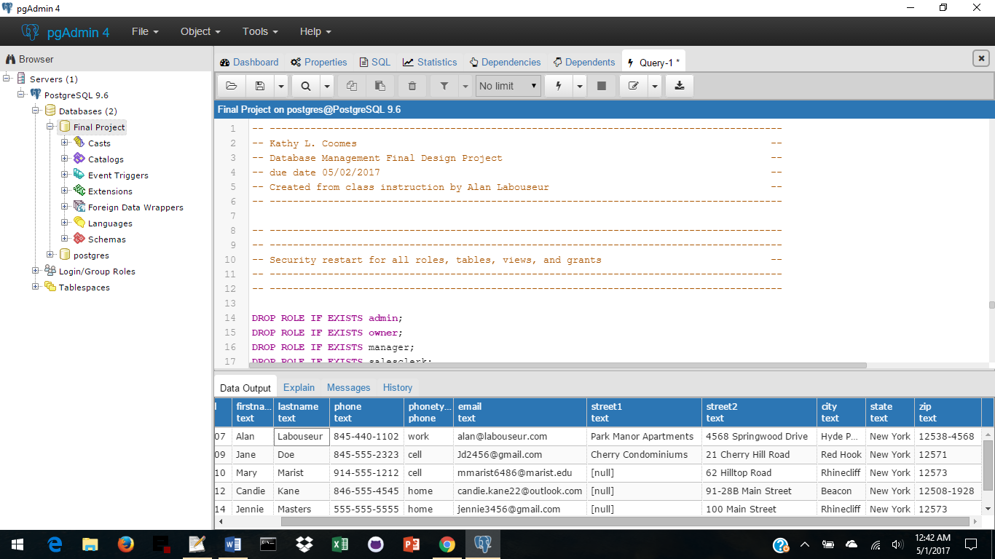

**Stored Procedures**

-- TEST DATA for AddPeople - VendorContacts:

Select AddPeople('V', 'people025', 'George', 'Baker', '555-555-5555', 'work',

'george@directfloral.com', NULL, '3657 Floral Drive', 'Pleasant Valley', 'New York',

'12569', NULL, NULL, NULL, NULL, NULL, 'vendor002');

SELECT * FROM VendorInfo;

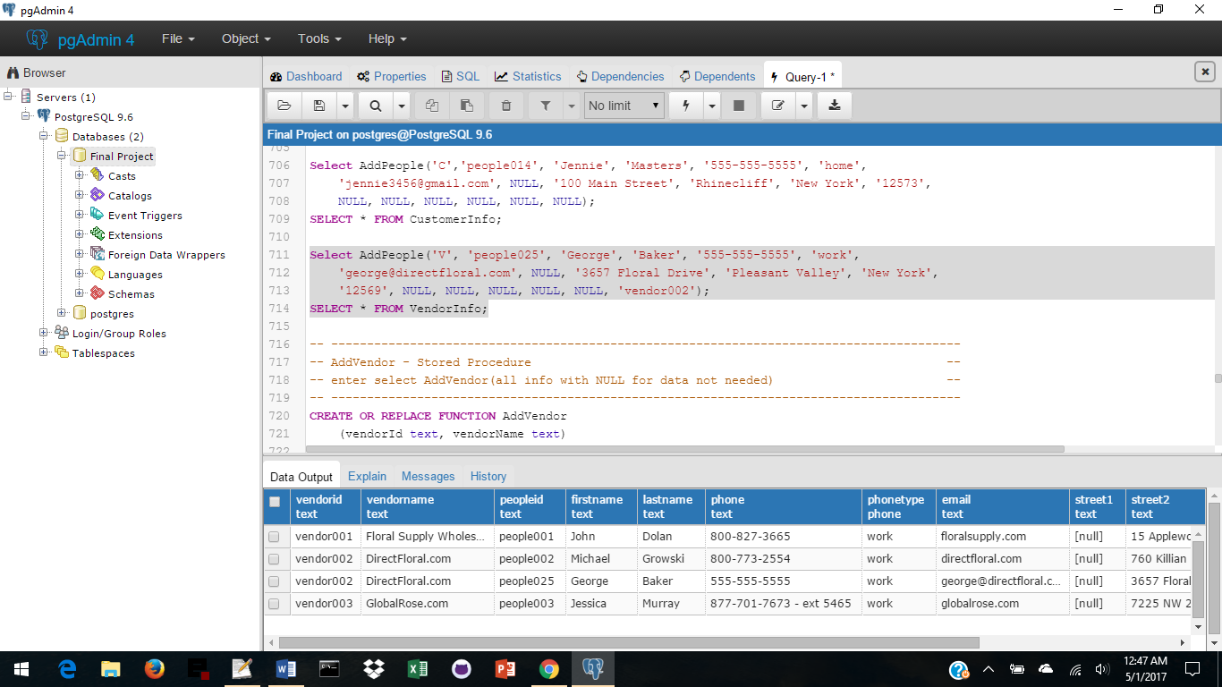

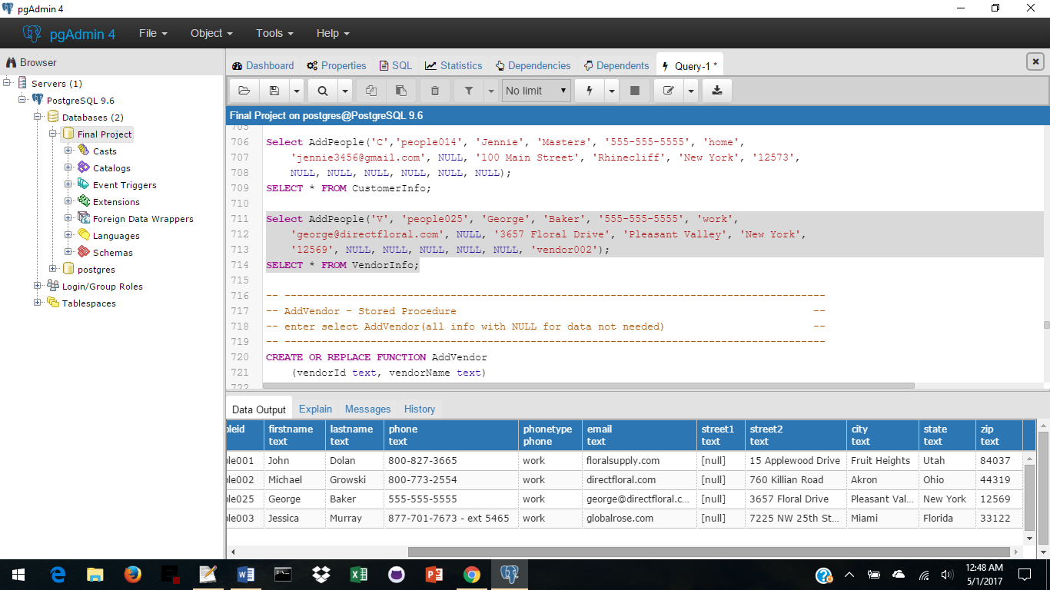

**Stored Procedures**

-- -----------------------------------------------------------------------

**AddVendor -**

enter select AddVendor(enter spots with NULL for data not needed)

-- -----------------------------------------------------------------------

CREATE OR REPLACE FUNCTION AddVendor

(vendorId text, vendorName text)

RETURNS void AS

$$

BEGIN

INSERT INTO Vendors

VALUES (vendorId, vendorName);

END

$$

LANGUAGE plpgsql;

-- Test Data:

Select AddVendor('vendor005', ‘Florist ExtraOrdinary’);

Select * FROM Vendors;

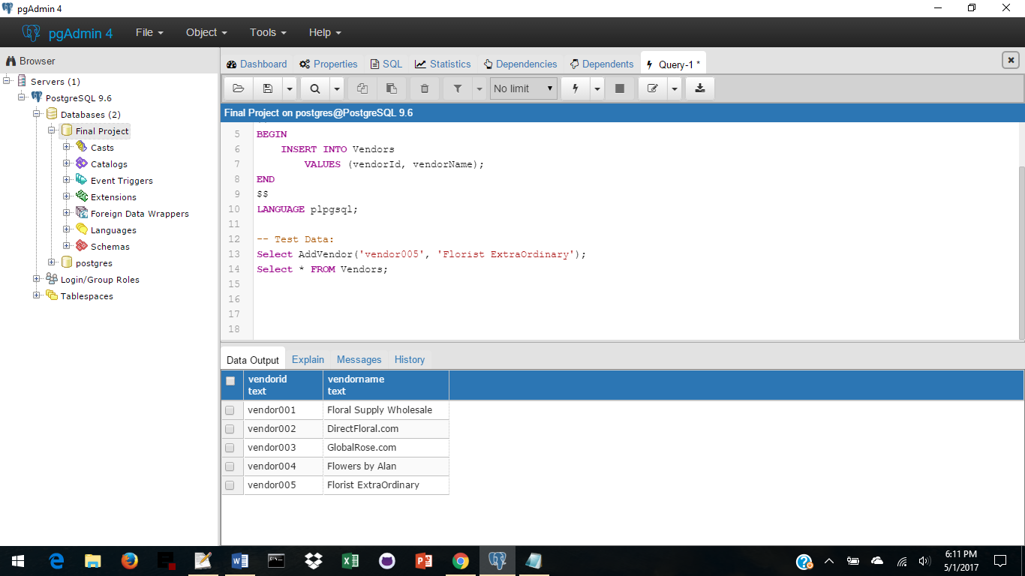

**Stored Procedures**

-- -----------------------------------------------------------------------

**AddProducts -**

adds information to Products, ProductHistory and Inventory

once a Product order has been received -- updates or inserts new

-- -----------------------------------------------------------------------

CREATE OR REPLACE FUNCTION AddProducts

(productNew text, newVendorProductId text, vendorId text, newProductType text,

newProductName text, newProductSize text, newProductColor text, newProductQty int,

newCurrentCostUSD numeric, newProductDesc text, historyCostUSD numeric,

dateBought date, newItemId text, NewItemName text, newInvQty int)

RETURNS void AS $$

BEGIN

IF productNew = 'Y' THEN

INSERT INTO Products

VALUES (newVendorProductId, vendorId, newProductType, newProductName, newProductSize, newProductColor, newProductQty, newCurrentCostUSD, newProductDesc);

INSERT INTO ArrangementItems

VALUES (newItemId, newItemName);

INSERT INTO Inventory

VALUES(newVendorProductId, newItemId, newInvQty);

INSERT INTO ProductHistory

VALUES(newVendorProductId, historyCostUSD, dateBought);

END IF;

IF productNew = 'N' THEN

UPDATE Products SET

productType = newProductType,

productName = newProductName,

productSize = newProductSize,

productColor = newProductColor,

productQty = newProductQty,

currentCostUSD = newCurrentCostUSD,

productDesc = newProductDesc

WHERE vendorProductId = newVendorProductId;

INSERT INTO ProductHistory

VALUES(newVendorProductId, historyCostUSD, dateBought);

UPDATE Inventory SET invQty = invQty + newInvQty

WHERE vendorproductId = newVendorProductId and itemId = newItemId;

END IF;

END

$$ LANGUAGE plpgsql;

**Stored Procedures**

-- TEST DATA – Add new product:

SELECT AddProducts('Y', 'G10026BH', 'vendor003', 'flower', 'rose', 'long stem',

'red', 12, 15, NULL, 15, '04/30/2017', 'item034', 'red roses', 12);

SELECT * FROM Products;

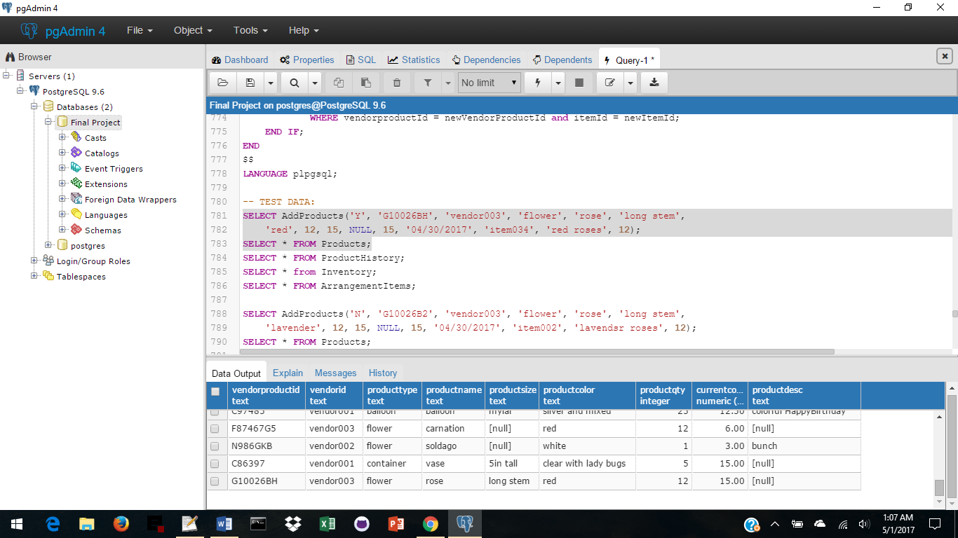

SELECT * FROM ProductHistory; SELECT * from Inventory; SELECT * FROM ArrangementItems;

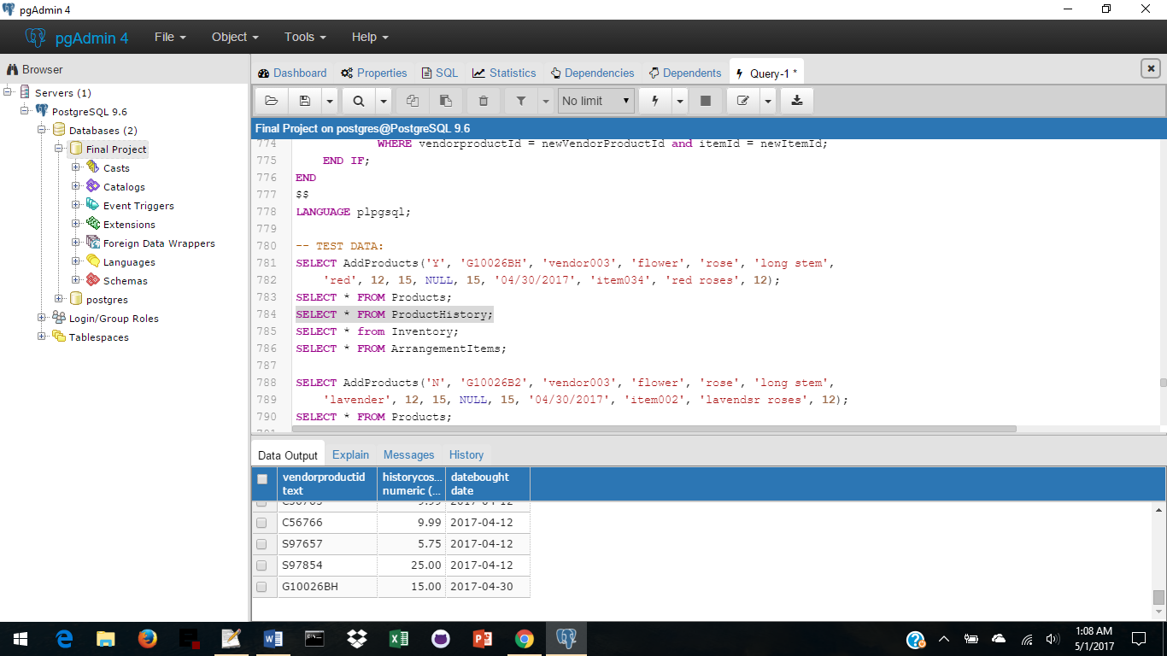 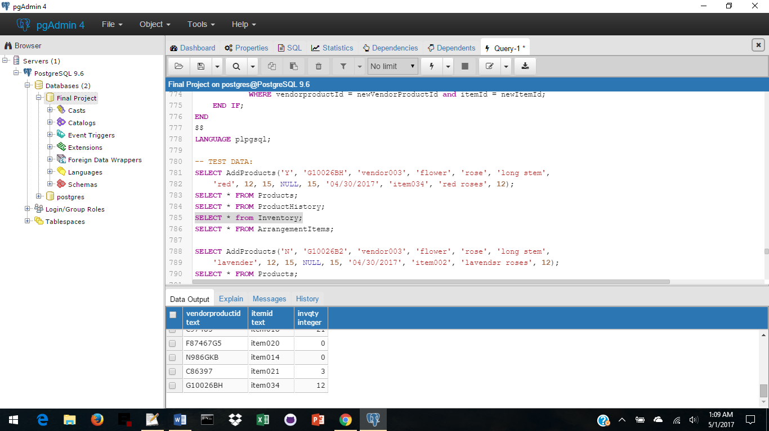 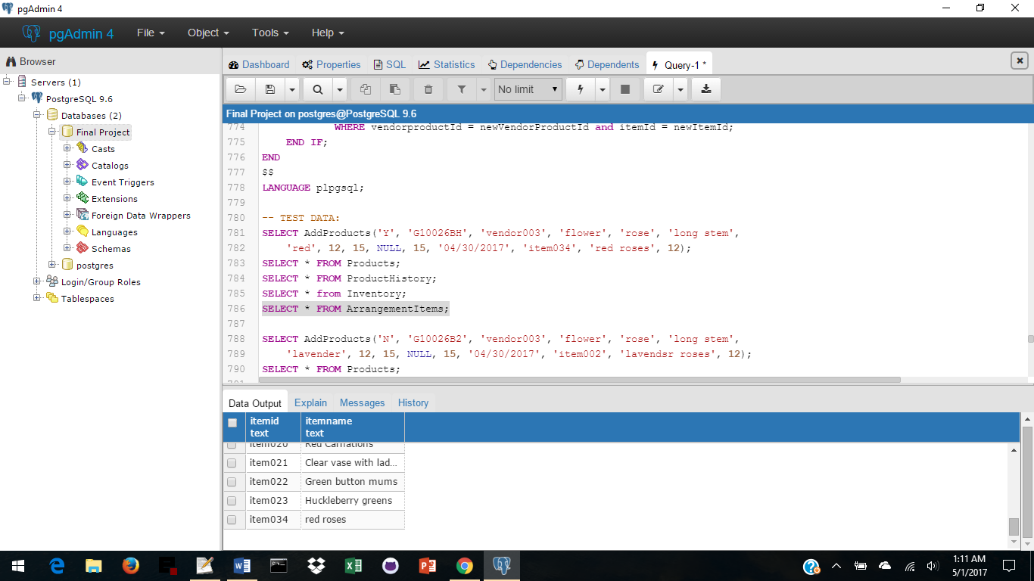

-- TEST DATA – Update a product:

SELECT AddProducts('N', 'G10026B2', 'vendor003', 'flower', 'rose', 'long stem',

'lavender', 12, 15, NULL, 15, '04/30/2017', 'item002', 'lavender roses', 12);

SELECT * FROM Products;

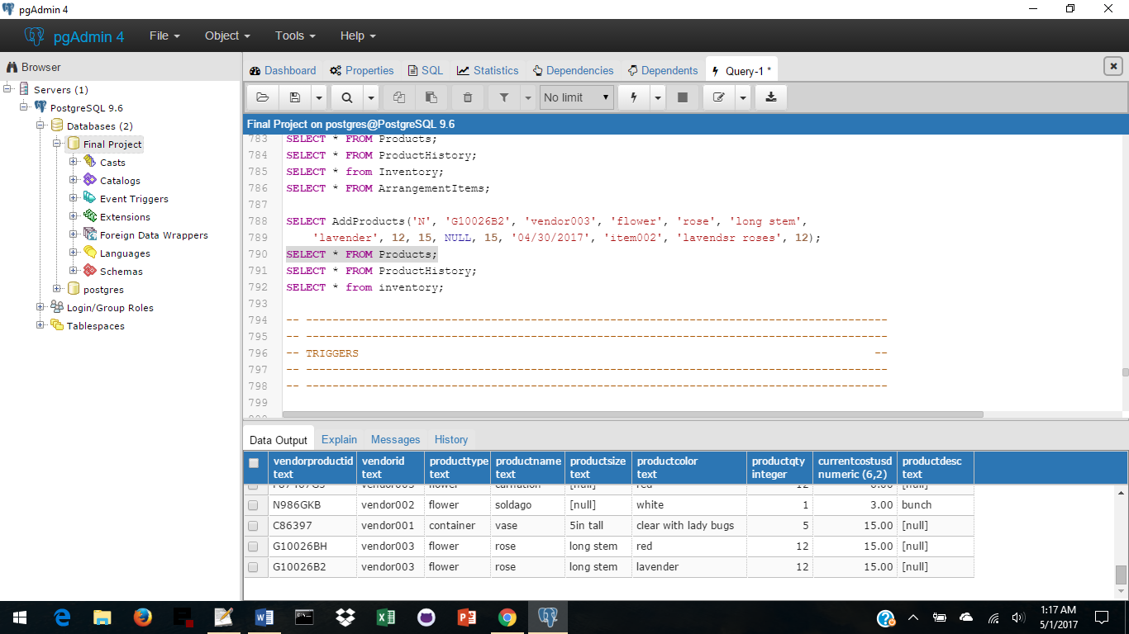

SELECT * FROM ProductHistory; SELECT * from inventory;

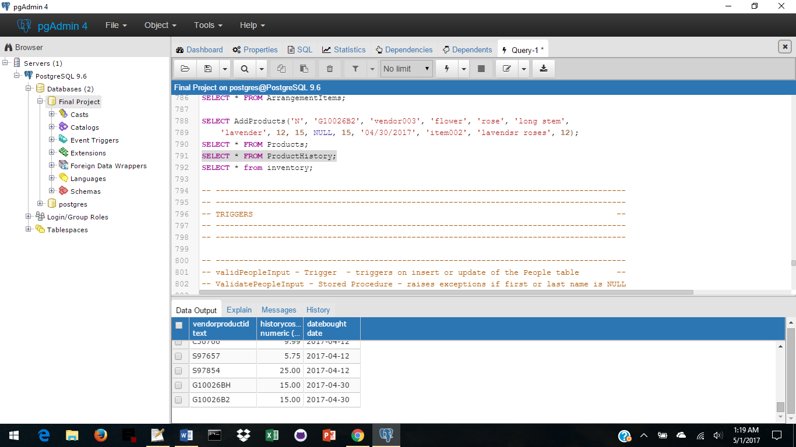 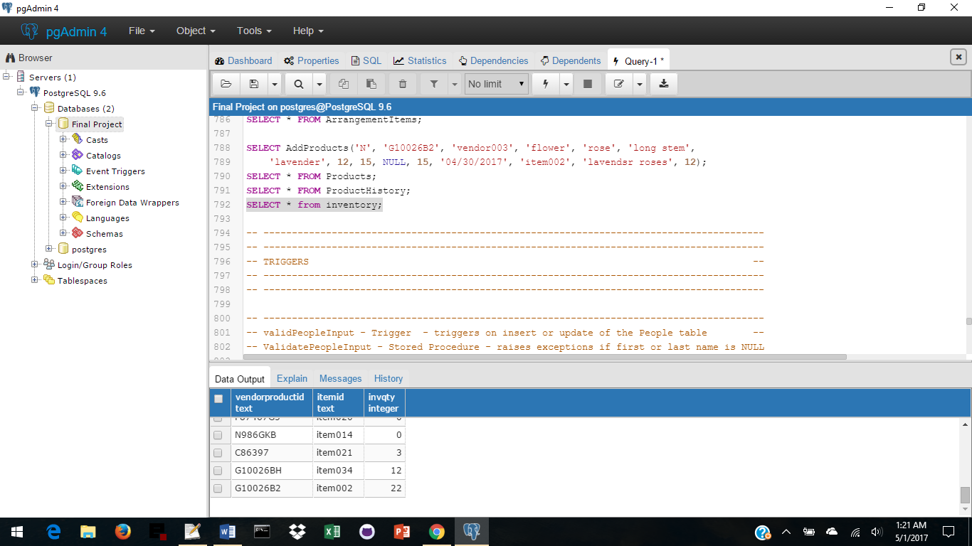

**Stored Procedures**

------------------------------------------

**Find Alan Report** - Finds Alan or Labouseur anywhere in the database

**Created by Daniel Verite and shared on3 Stack Overflow on 4/12/2014 under the title of**

**'How to search a specific value in all tables (PostgreSQL)?'** works in version 9.1 or newer

He stated the following:

"Here is a pl/pgsqlfunction that locates records where any column contains a specific value.

It takes as arguments the value to search in text format, an array of table names to search into (defaults to all tables) and an array of schema names (public by default. It returns a table structure with schema, name of table, name of column and pseudo-column ctid (non-durable physical location of the row in the table."

-- -----------------------------------------------------------------------

CREATE OR REPLACE FUNCTION search_columns(

needle text,

haystack_tables name[] default '{}',

haystack_schema name[] default '{public}'

)

RETURNS table(schemaname text, tablename text, columnname text, rowctid text)

AS $$

begin

FOR schemaname,tablename,columnname IN

SELECT c.table_schema,c.table_name,c.column_name

FROM information_schema.columns c

JOIN information_schema.tables t ON

(t.table_name=c.table_name AND t.table_schema=c.table_schema)

WHERE (c.table_name=ANY(haystack_tables) OR haystack_tables='{}')

AND c.table_schema=ANY(haystack_schema)

AND t.table_type='BASE TABLE'

LOOP

EXECUTE format('SELECT ctid FROM %I.%I WHERE cast(%I as text)=%L',

schemaname,

tablename,

columnname,

needle

) INTO rowctid;

IF rowctid is not null THEN

RETURN NEXT;

END IF;

END LOOP;

END;

$$ language plpgsql;

**Stored Procedures**

SELECT * FROM search_columns('Alan');

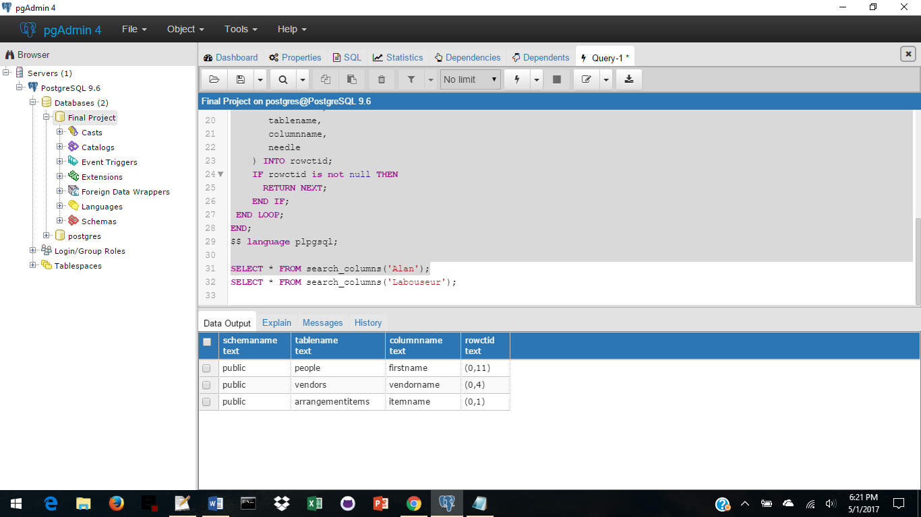

SELECT * FROM search_columns('Labouseur');

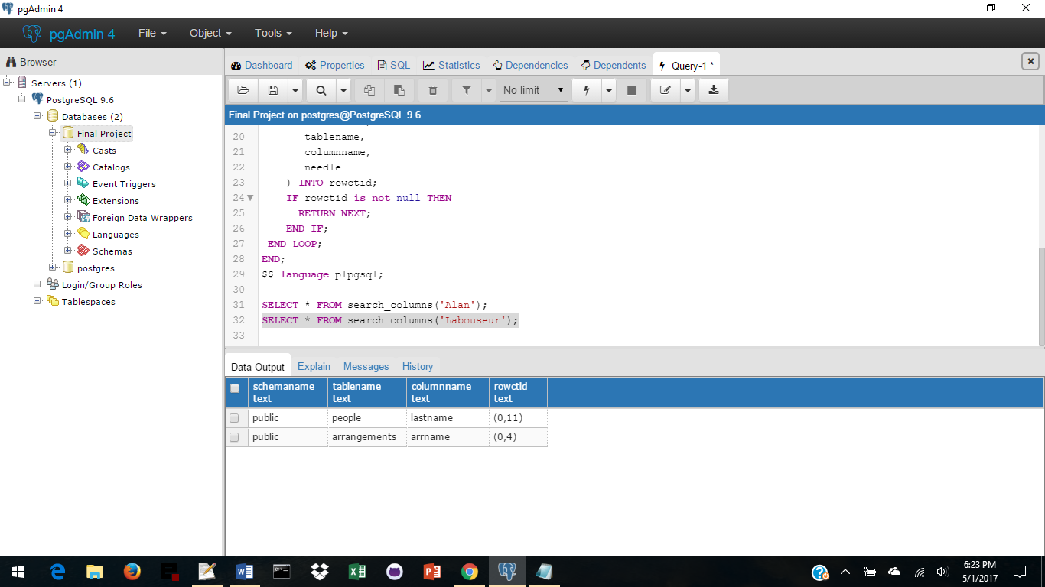

**Triggers**

-- -----------------------------------------------------------------------

Trigger – **validPeopleInput**

Stored Procedure - **ValidatePeopleInput()**

Triggers on a new entry or update in the People table

-- -----------------------------------------------------------------------

CREATE OR REPLACE FUNCTION ValidatePeopleInput()

RETURNS TRIGGER AS

$$

BEGIN

IF NEW.firstName IS NULL THEN

RAISE EXCEPTION 'firstName may not be NULL';

END IF;

IF NEW.lastName IS NULL THEN

RAISE EXCEPTION 'lastName may not be NULL';

END IF;

RETURN NEW;

END

$$

LANGUAGE plpgsql;

-- -----------------------------------------------------------------------

CREATE TRIGGER validPeopleInput

BEFORE INSERT OR UPDATE ON People

FOR EACH ROW

EXECUTE PROCEDURE ValidatePeopleInput();

-- -----------------------------------------------------------------------

**Test Data**

INSERT INTO People (peopleId, firstName, lastName)

VALUES('people013', NULL, NULL);

INSERT INTO People (peopleId, firstName, lastName)

VALUES('people013' Joyce, NULL);

**Results:**

ERROR: firstName may not be NULL

CONTEXT: PL/pgSQL function validatepeopleinput() line 4 at RAISE

ERROR: lastName may not be NULL

CONTEXT: PL/pgSQL function validatepeopleinput() line 7 at RAISE

**Triggers**

-- -----------------------------------------------------------------------

Trigger - **ValidVendorInput**

Stored Procedure - **ValidateVendorInput**

Triggers on insert or update of the Vendor table

-- -----------------------------------------------------------------------

CREATE OR REPLACE FUNCTION ValidateVendorInput()

RETURNS TRIGGER AS

$$

BEGIN

IF NEW.vendorId IS NULL THEN

RAISE EXCEPTION 'vendorId may not be NULL';

END IF;

IF NEW.vendorName IS NULL THEN

RAISE EXCEPTION 'vendorName may not be NULL';

END IF;

RETURN NEW;

END

$$

LANGUAGE plpgsql;

-- -----------------------------------------------------------------------

CREATE TRIGGER ValidVendorInput

BEFORE INSERT OR UPDATE ON Vendors

FOR EACH ROW

EXECUTE PROCEDURE ValidateVendorInput();

-- -----------------------------------------------------------------------

**Test Data**

INSERT INTO Vendors (vendorId, vendorName)

VALUES(NULL, 'LabouseursPlace');

INSERT INTO Vendors (vendorId, vendorName)

VALUES('vendor234', NULL);

**Results:**

ERROR: vendorId may not be NULL

CONTEXT: PL/pgSQL function validatevendorinput() line 4 at RAISE

ERROR: vendorName may not be NULL

CONTEXT: PL/pgSQL function validatevendorinput() line 7 at RAISE

**Views**

-- -----------------------------------------------------------------------

**VendorInfo – A view with 2 reports to obtain Vendor Information**

from People, Addresses, Zips, Vendors, VendorContacts

-- -----------------------------------------------------------------------

CREATE VIEW VendorInfo

AS

SELECT v.vendorId, v.vendorName, vc.peopleId, p.firstName, p.lastName, p.phone,

p.phoneType, p.email, a.street1, a.street2, a.zip, z.city, z.state

FROM Vendors v,

VendorContacts vc,

People p,

Addresses a,

Zips z

WHERE v.vendorId = vc.vendorId and

vc.peopleId = p.peopleId and

p.peopleId = a.peopleId and

a.zip = z.zip

ORDER BY v.vendorId ASC;

**-- ----------------query 1 - all Vendor Information ---------------------**

SELECT * FROM VendorInfo;

**Sample Data:**

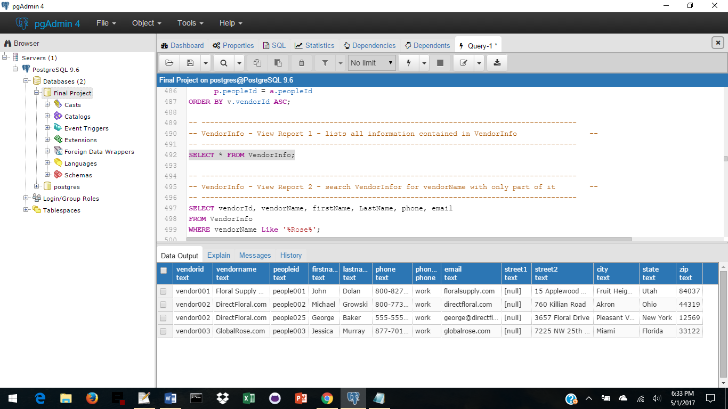

**-- ----------------query 2 - search for an unknown name ------------------**

SELECT vendorId, vendorName, firstName, LastName, phone, email

FROM VendorInfo

WHERE vendorName Like '%Rose%';

**Sample Data:**

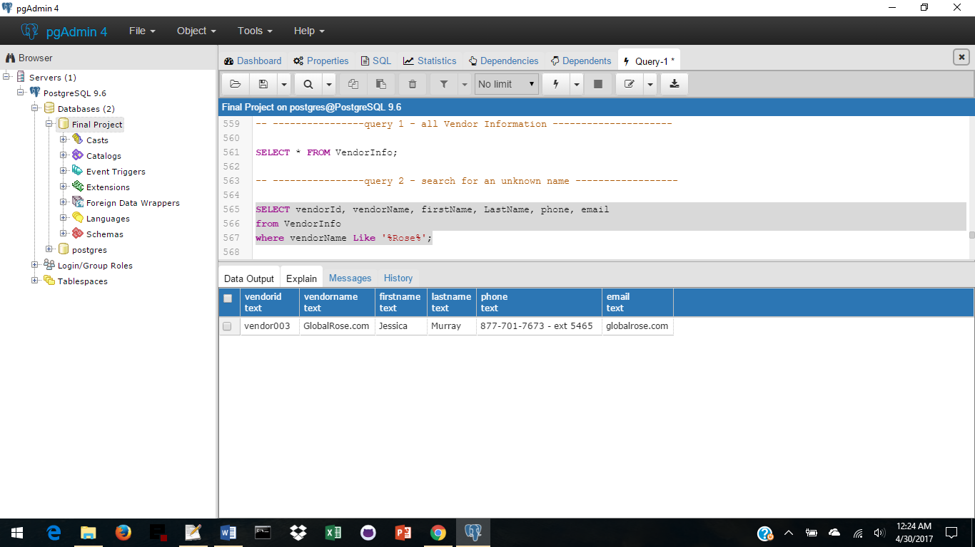

**Views**

-- -----------------------------------------------------------------------

**StaffInfo – A view with 4 reports to obtain Vendor Information**

from People, Addresses, Zips, Staff

-- -----------------------------------------------------------------------

CREATE VIEW StaffInfo

AS

SELECT s.peopleId, s.dateHired, s.hiredPosition, s.dateLeft, s.position, s.cellPhone,

p.firstName, p.lastName, p.phone, p.phoneType, p.email, a.street1, a.street2,

a.zip, z.city, z.state

FROM Staff s,

People p,

Addresses a,

Zips z

WHERE s.peopleId = p.peopleId and

p.peopleId = a.peopleId and

a.zip = z.zip

ORDER BY s.peopleId ASC;

**-- ---- query 1 - all Staff Information ----------------------------------**

SELECT * FROM StaffInfo;

**Sample Data:**

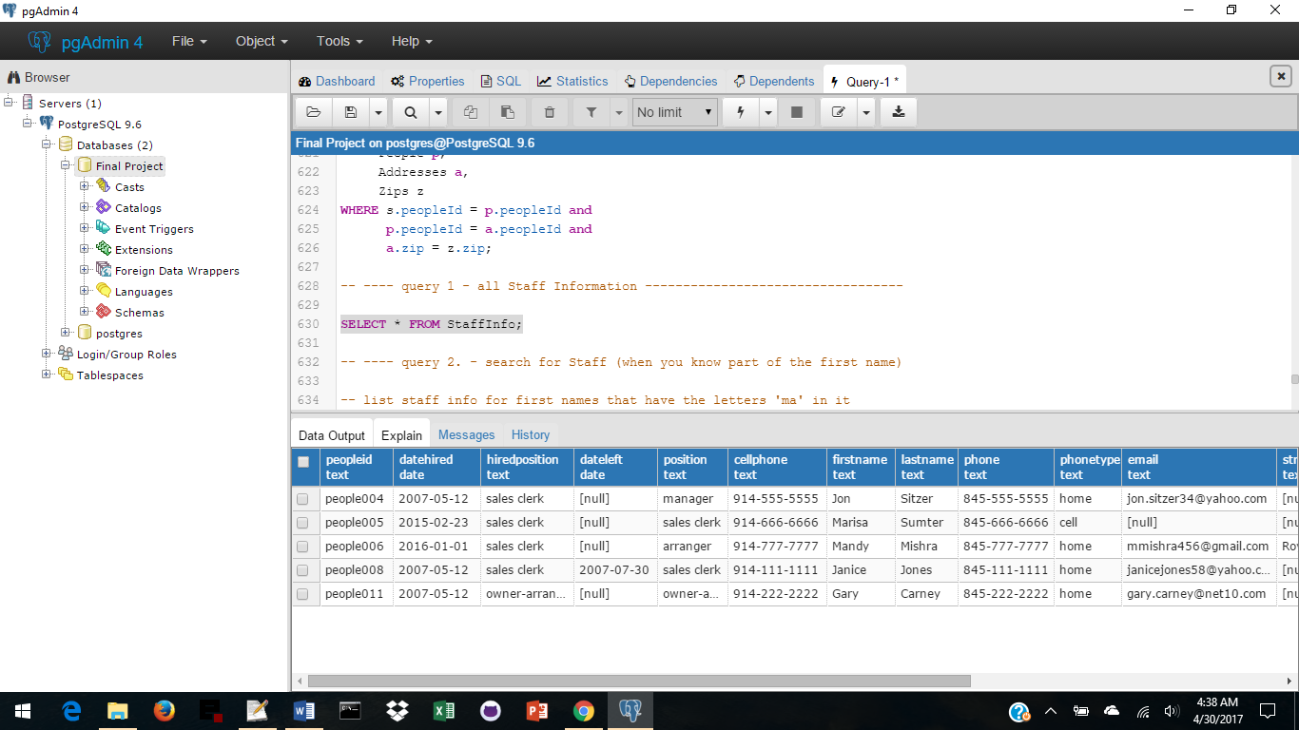

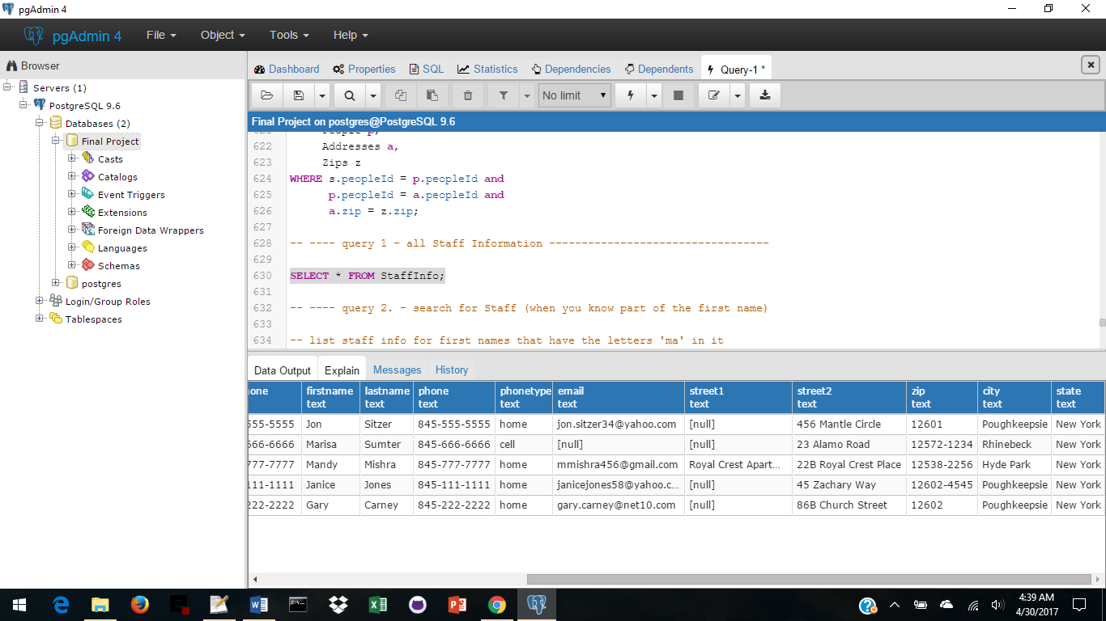

**Views**

**-- ---- query 2. - search for Staff (when you know part of the first name)**

-- list staff info for first names that have the letters 'ma' in it

SELECT firstName, LastName, cellPhone, phone, phoneType, email

FROM StaffInfo

WHERE firstName Like 'Ma%'

ORDER BY firstName DESC;

**Sample Data:**

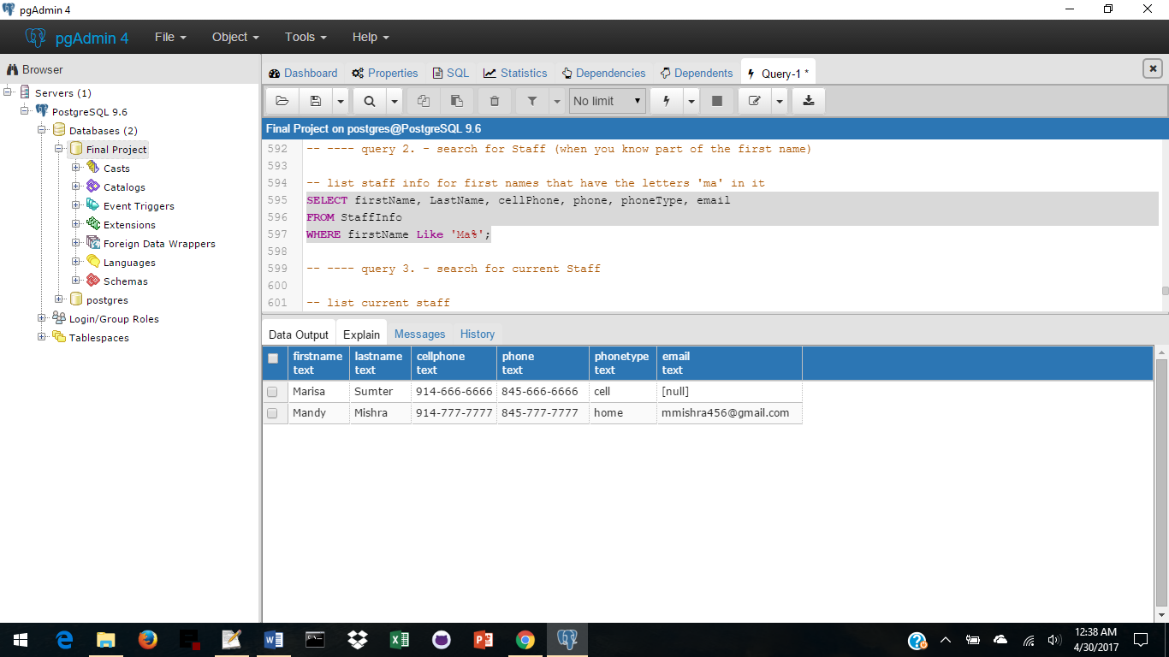

**-- ---- query 3. - search for current Staff**

-- list current staff

SELECT firstName, LastName, dateHired, hiredPosition, position

FROM StaffInfo

WHERE dateLeft is Null

ORDER BY dateHired DESC;

**Sample Data:**

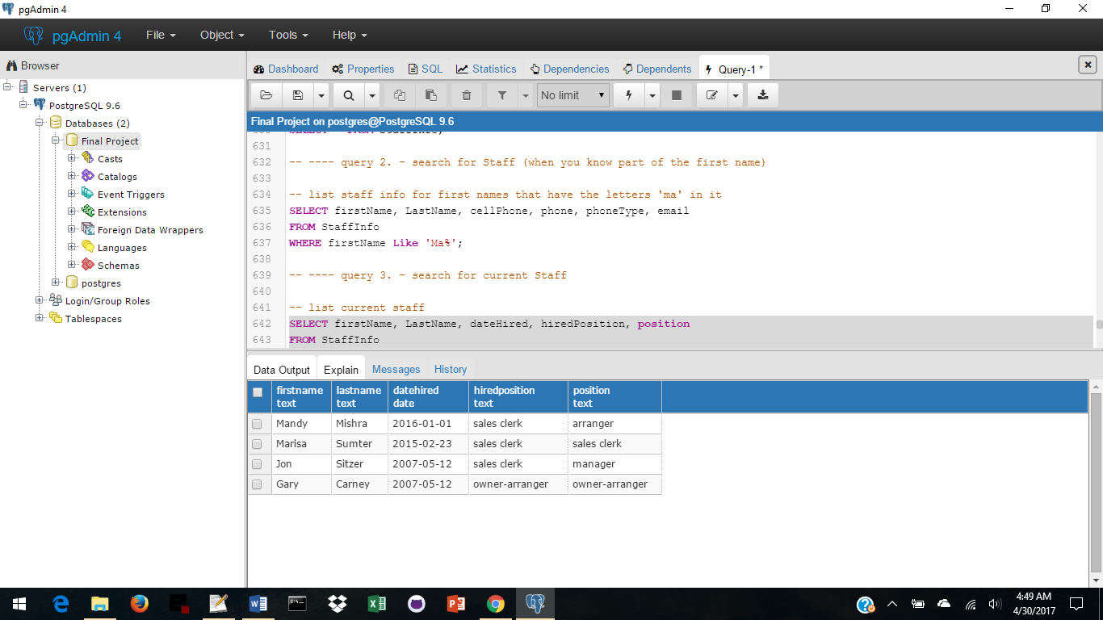

**-- ---- query 4. - search for Staff who have left**

-- list staff who are no longer with the company

SELECT firstName, LastName, dateHired, hiredPosition, position

FROM StaffInfo

WHERE dateLeft is not Null;

**Sample Data:**

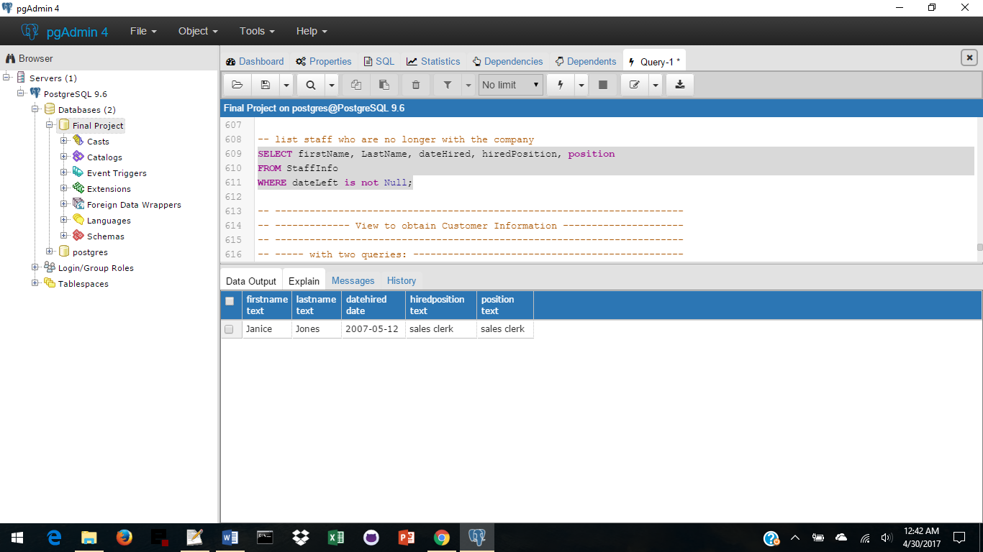

**Views**

-- -----------------------------------------------------------------------

**CustomerInfo – A view with 4 reports to obtain Customer Information**

from People, Addresses, Zips, Customers

-- -----------------------------------------------------------------------

CREATE VIEW CustomerInfo

AS

SELECT c.peopleId, p.firstName, p.lastName, p.phone, p.phoneType, p.email,

a.street1, a.street2, a.zip, z.city, z.state

FROM Customers c,

People p,

Addresses a,

Zips z

WHERE c.peopleId = p.peopleId and

p.peopleId = a.peopleId and

a.zip = z.zip

ORDER BY c.peopleId ASC;

**-- ---- query 1 - all Customer Information -------------------------------**

SELECT * FROM CustomerInfo;

**Sample Data:**

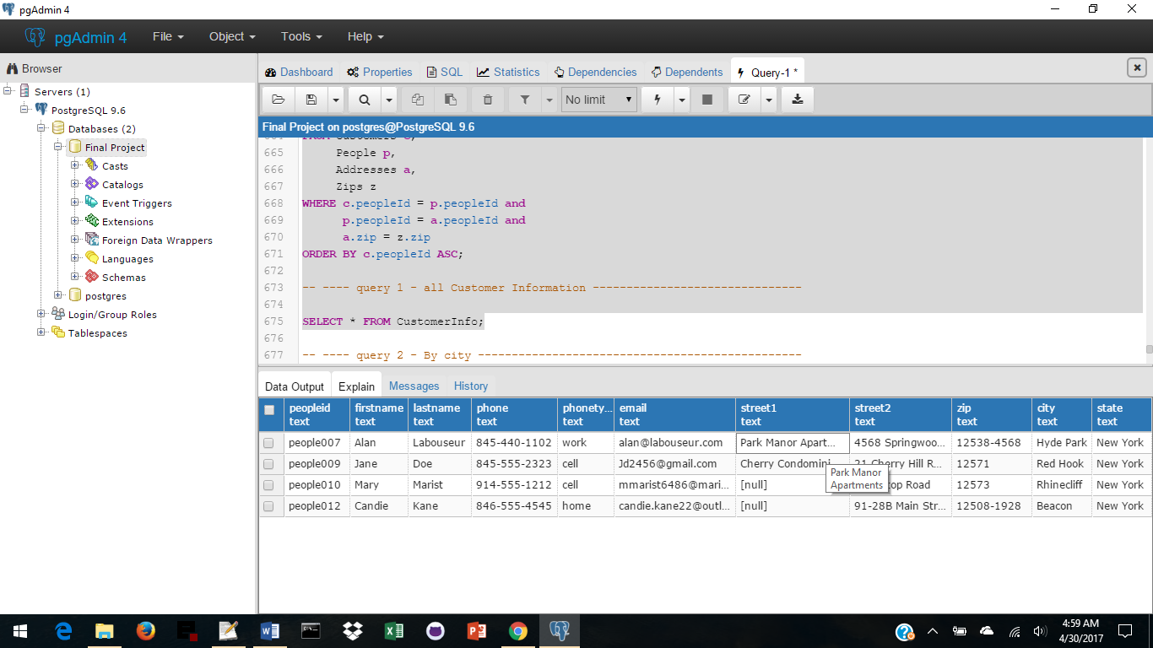

**-- ---- query 2 - By city ------------------------------------------------**

-- list customer info for cities that start with 'R'

SELECT firstName, LastName, phone, phoneType, email, city

FROM CUSTOMERINFO

where city Like 'R%';

**Sample Data:**

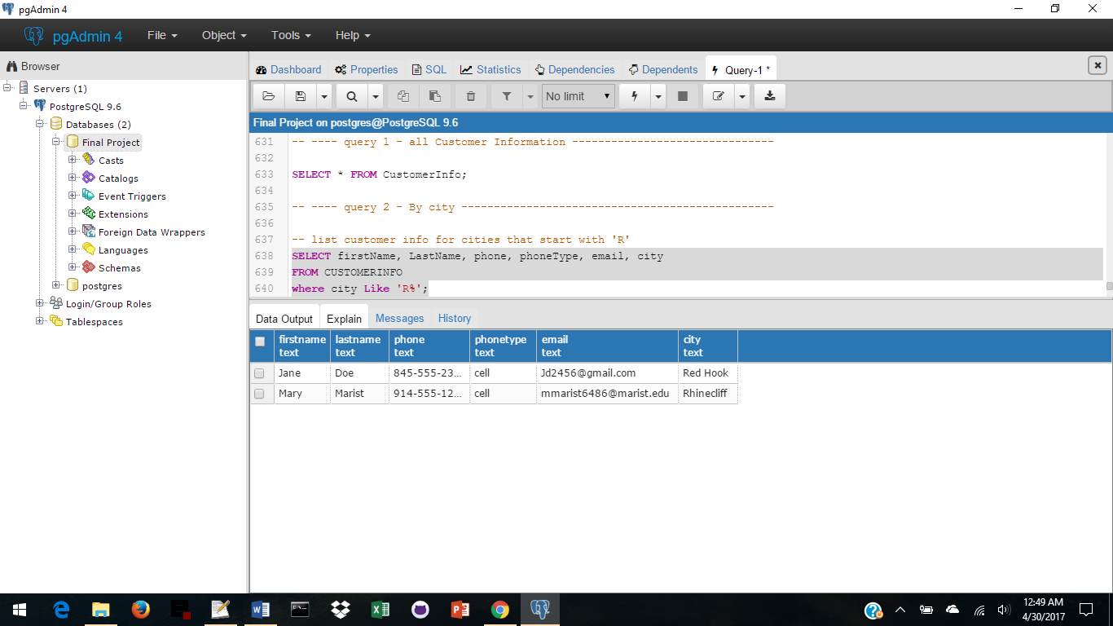

**Views**

-- -----------------------------------------------------------------------

**ProductInfo – A view with 2 reports to obtain Product Information**

from Vendors, Products, ProductHistory

-- -----------------------------------------------------------------------

CREATE VIEW ProductInfo

AS

SELECT c.vendorId, c.vendorName, h.vendorProductId, p.productType, p.productName,

p.productSize, p.productColor, p.productQty, p.currentCostUSD, p.productDesc, h.dateBought,h.historyCostUSD

FROM Vendors c,

Products p,

ProductHistory h

WHERE c.vendorId = p.vendorId and

p.vendorProductId = h.vendorProductId;

**-- ---- query 1 - all Product Information ----------------------**

SELECT * from ProductInfo;

**Sample Data:**

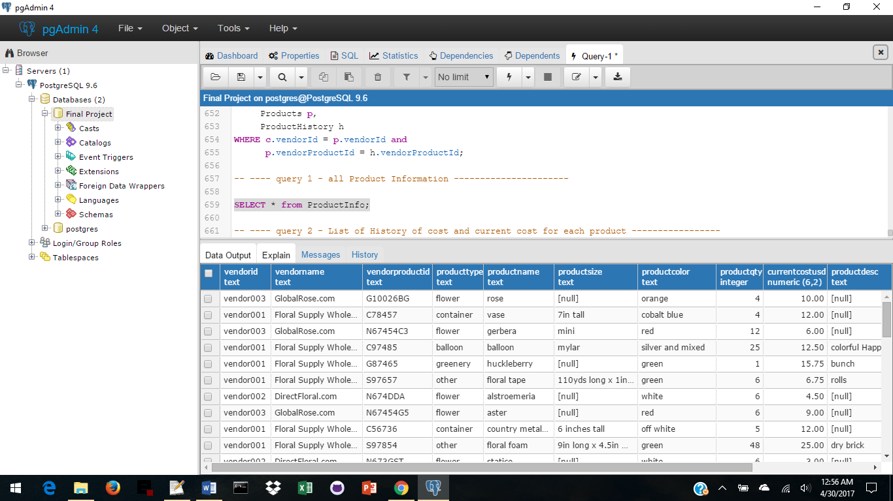

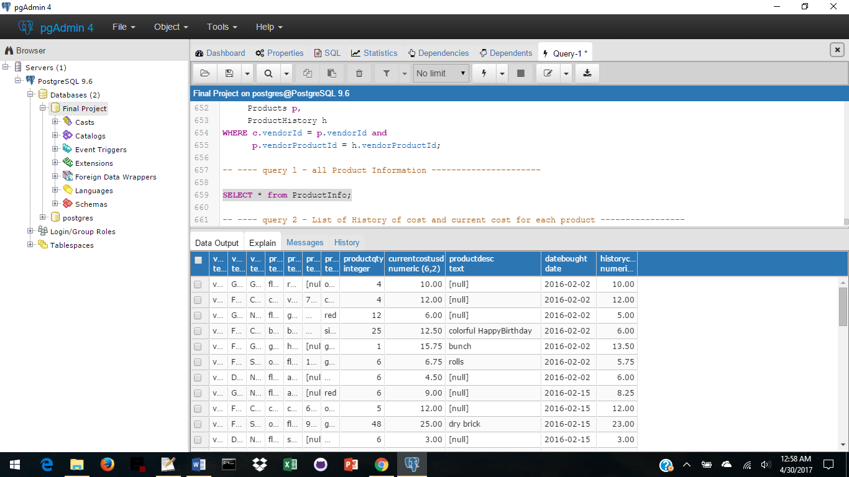

**Views**

**-- ---- query 2 - List of History of cost and current cost for each product -----------------**

SELECT vendorProductId, productName, productSize, productQty, currentCostUSD, dateBought, historyCostUSD

FROM ProductInfo

ORDER BY vendorProductId, dateBought;

**Sample Data:**

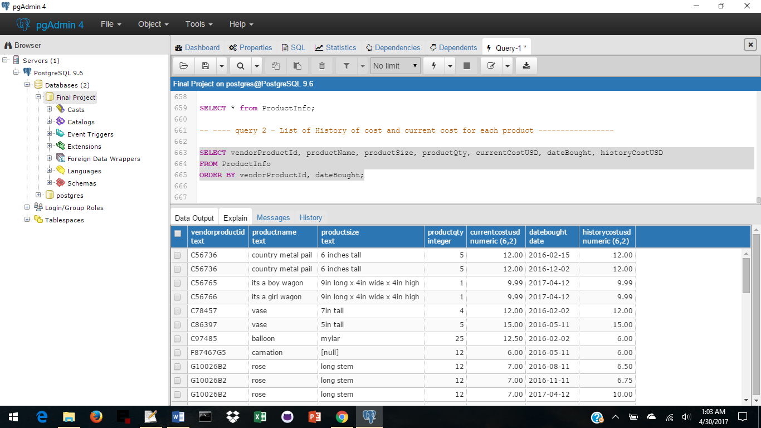

**Reports**

-- -----------------------------------------------------------------------

Reports that **list all** from each of the tables.

Results were listed with each table create:

-- -----------------------------------------------------------------------

SELECT * FROM People;

SELECT * FROM Vendors;

SELECT * FROM VendorContacts;

SELECT * FROM Staff;

SELECT * FROM Customers;

SELECT * FROM Zips;

SELECT * FROM Addresses;

SELECT * FROM Products;

SELECT * FROM ProductHistory;

SELECT * FROM Arrangements;

SELECT * FROM ArrangementItems;

SELECT * FROM ArrangementItemsList;

SELECT * FROM Inventory;

-- -----------------------------------------------------------------------

**List Items used in an Arrangement and their quantity**

Report to obtain a list of items needed for an arrangement.

-- -----------------------------------------------------------------------

SELECT a.arrId, p.itemId, p.itemName, apl.itemQty

FROM Arrangements a INNER JOIN ArrangementItemsList apl ON a.addId = apl.arrId

INNER JOIN ArrangementItems p ON apl.itemId = p.itemId

WHERE a.arrId = 'arr001'

ORDER BY p.itemId ASC;

**Sample Data:**

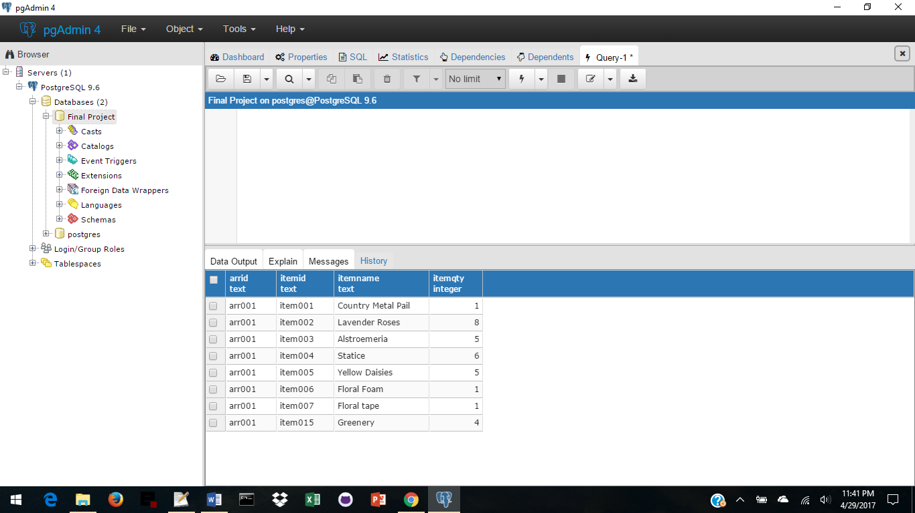

**Reports**

-- -----------------------------------------------------------------------

**Vendors with no contact person**

Report finds Vendors who have no Vendor Contacts

-- -----------------------------------------------------------------------

SELECT *

FROM Vendors

WHERE vendorId not in

(SELECT vendorId

FROM VendorContacts

)

ORDER BY vendorName;

Sample Data:

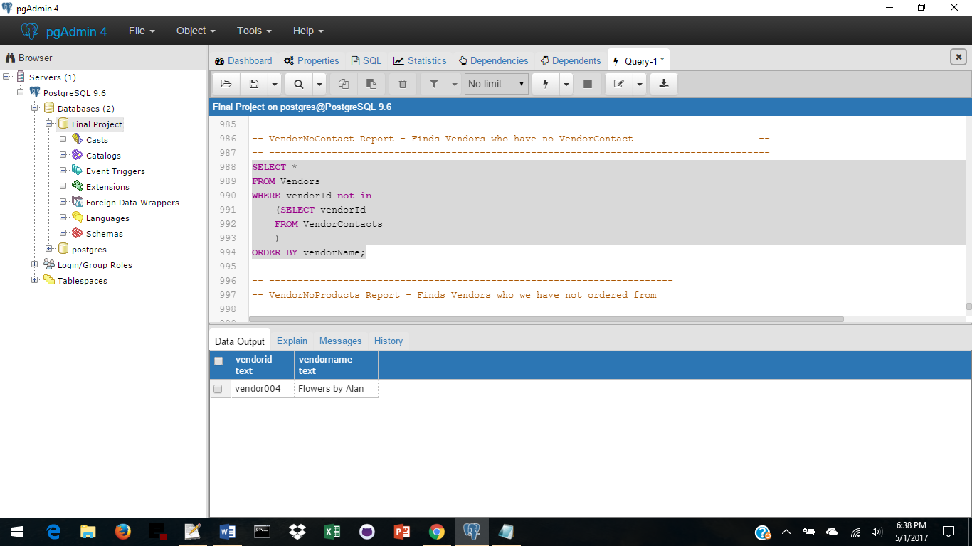

-- -----------------------------------------------------------------------

**Vendors with no products**

Report finds Vendors who we have not ordered from

-- -----------------------------------------------------------------------

SELECT *

FROM Vendors

WHERE vendorId not in

(SELECT vendorId

FROM Prooducts

)

ORDER BY vendorName;

Sample Data:



**Reports**

-- -----------------------------------------------------------------------

**Vendor Most Used**

Report finds Vendor who we order the most from

-- -----------------------------------------------------------------------

SELECT v.vendorId as "Vendor ID",

v.vendorName as "Vendor Name",

count(v.vendorId) as "Product Orders Numbers"

FROM Vendors v INNER JOIN Products p ON v.vendorId = p.vendorId

INNER JOIN ProductHistory ph ON p.vendorProductId = ph.vendorProductId

GROUP BY v.vendorId

ORDER BY count(v.vendorId) DESC

limit 1;

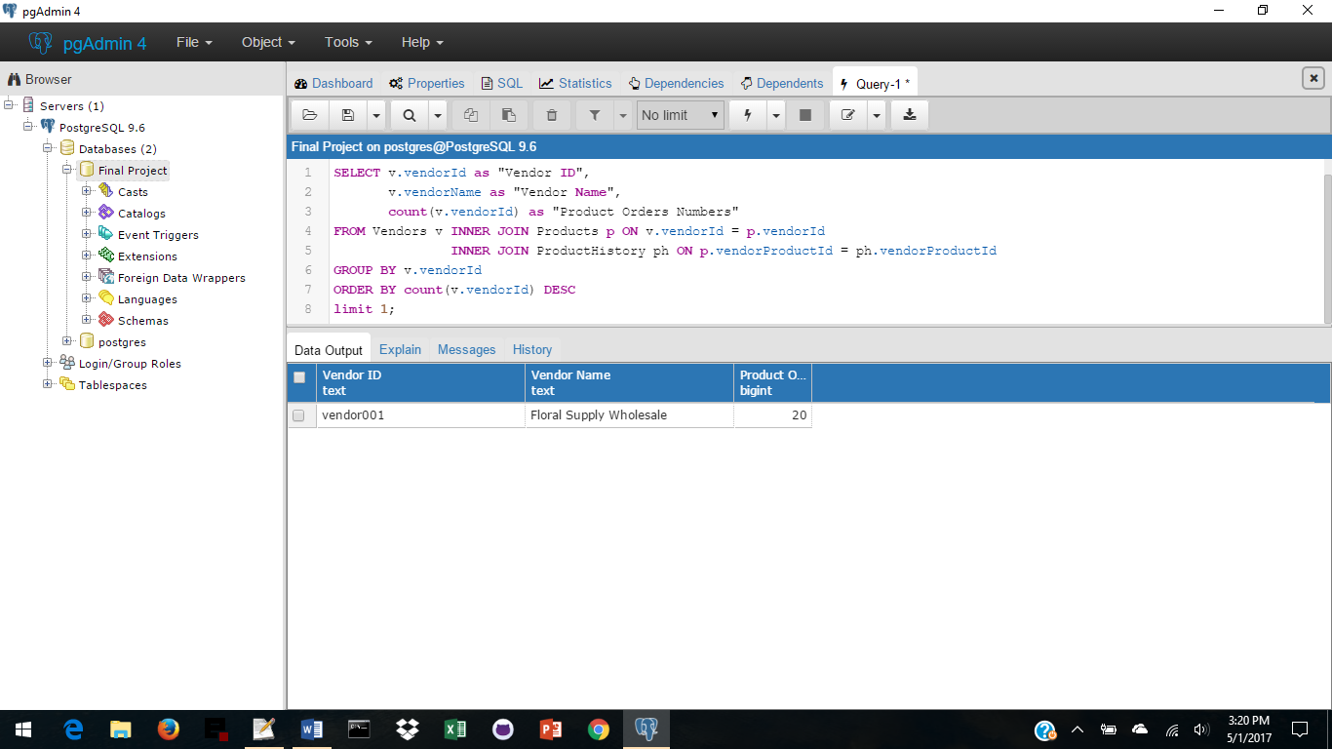

-- -----------------------------------------------------------------------

**Find Vendor City**

Finds Vendors in a particular City -

-- -----------------------------------------------------------------------

SELECT v.vendorName as "Vendor Name"

FROM Vendors v

WHERE v.vendorId in

(SELECT distinct vc.vendorId

FROM VendorContacts vc

WHERE vc.peopleId in

(SELECT p.peopleId

FROM People p

WHERE p.peopleId in

(SELECT a.peopleId

FROM Addresses a

WHERE a.city in ('Miami')

)

)

)

ORDER BY v.vendorName ASC;

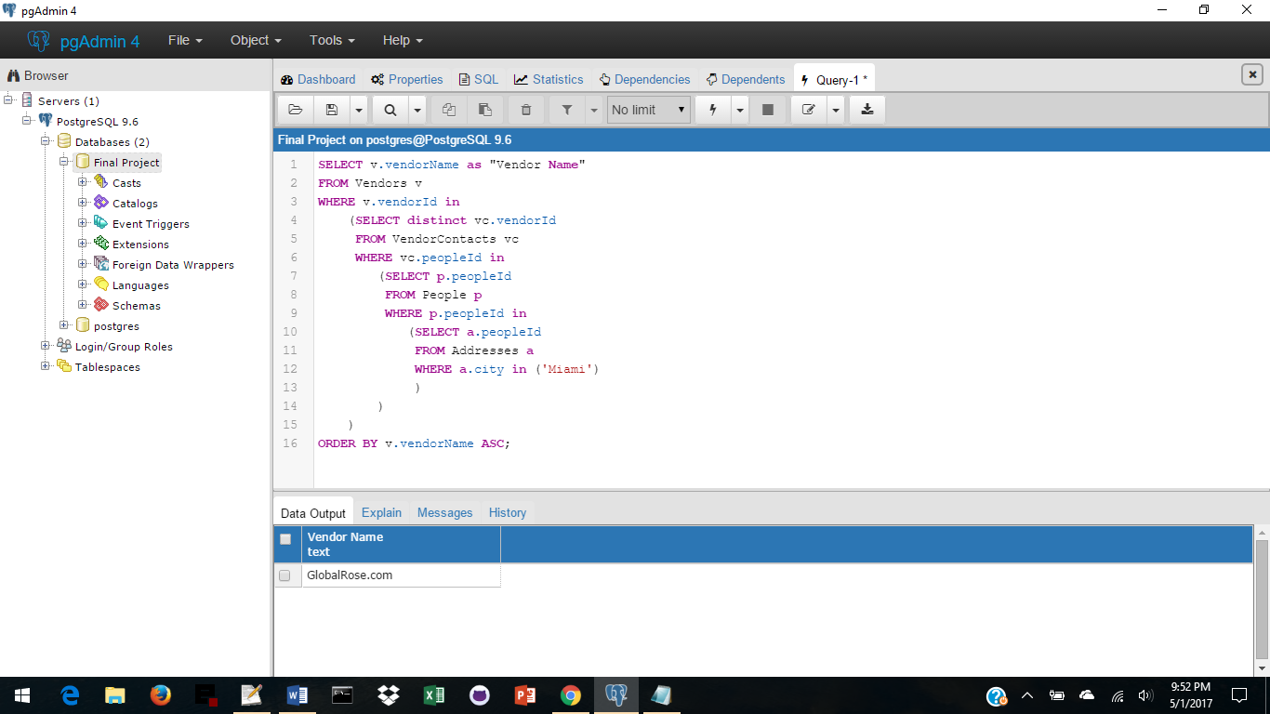

**Reports**

-- -----------------------------------------------------------------------

**AddVendors** - Calls the Stored Procedure AddVendors (test data is there)

-- -----------------------------------------------------------------------

-- example:

-- Select AddVendor('vendor004', 'WonderlandFlorist.com');

-- Use this below - remove the dashes first, replace the information

-- SELECT AddPeople('vendorId', 'vendorName');

-- -----------------------------------------------------------------------

**AddProducts** - Calls the Stored Procedure AddProducts (test data there)

-- -----------------------------------------------------------------------

--example1:

--SELECT AddProducts('Y', 'G10026BH', 'vendor003', 'flower', 'rose', 'long stem',

'red', 12, 15, NULL, 15, '04/30/2017', 'item034', 'red roses', 12);

--SELECT AddProducts('N', 'G10026B2', 'vendor003', 'flower', 'rose', 'long stem',

'lavender', 12, 15, NULL, 15, '04/30/2017', 'item002', 'lavendsr roses', 12);

-- Use this below - remove the dashes first, replace the information

-- SELECT AddProducts('productNew', 'newVendorProductId', 'vendorId', 'newProductType',

-- 'newProductName', 'newProductSize', 'newProductColor', 'newProductQty',

-- 'newCurrentCostUSD', 'newProductDesc', 'historyCostUSD','dateBought', 'newItemId',

-- 'newItemName', 'newInvQty');

-- -----------------------------------------------------------------------

-- There are more reports attached to all the views and stored procedures

-- -----------------------------------------------------------------------

**Roles and Security**

-- ----------------------------------------------------------------------------------------

-- ----------------------------------------------------------------------------------------

-- Security restart for all roles, tables, views, and grants --

-- ----------------------------------------------------------------------------------------

-- ----------------------------------------------------------------------------------------

DROP ROLE IF EXISTS admin;

DROP ROLE IF EXISTS owner;

DROP ROLE IF EXISTS manager;

DROP ROLE IF EXISTS salesclerk;

DROP TABLE IF EXISTS People, VendorContacts, Staff, Customers, Vendors, Addresses, Products,

Producthistory, Inventory, Arrangements, ArrangementItems, ArrangementItemsList CASCADE;

DROP VIEW IF EXISTS CompanyInfo, StaffInfo, CustomerInfo, ProductInfo CASCADE;

DROP TYPE IF EXISTS phone, prod, pos CASCADE;

DROP TRIGGER IF EXISTS validPeopleInput ON People CASCADE;

-- ----------------------------------------------------------------------------------------

-- Administrator Role - has full access --

-- ----------------------------------------------------------------------------------------

CREATE ROLE admin;

GRANT ALL ON ALL TABLES IN SCHEMA public TO admin;

-- ----------------------------------------------------------------------------------------

-- Owner Role - Owns the business, so has full access --

-- ----------------------------------------------------------------------------------------

CREATE ROLE owner;

GRANT ALL ON ALL TABLES IN SCHEMA public TO owner;

-- ----------------------------------------------------------------------------------------

-- Manager Role - the manager has access to insert or update in all tables --

-- ----------------------------------------------------------------------------------------

CREATE ROLE manager;

REVOKE ALL ON ALL TABLES IN SCHEMA public FROM manager;

GRANT ALL ON ALL TABLES IN SCHEMA public TO manager;

-- ----------------------------------------------------------------------------------------

-- Salesclerk Role - has ability to select all --

-- ----------------------------------------------------------------------------------------

CREATE ROLE salesclerk;

REVOKE ALL ON ALL TABLES IN SCHEMA public FROM salesclerk;

GRANT SELECT ON ALL TABLES IN SCHEMA public TO salesclerk;

**Implementation Notes**

With a much larger data sample (which would take more than the time given and would make this project extremely unwieldy), there would be more chances to create more complex queries.

Also (to keep the project down to size), I have only included validation for input or update into two of the tables: People and Vendors as it would only be repetition.

I have included AddPeople, AddVendors, and AddProducts, but again due to size and time, I have not included AddArrangements (which would add to Arrangements, ArrangementItems, ArrangementItemsList, Inventory, Products and possibly Vendors, VendorContacts, People, and Addresses. When adding, it is required that the information for each be entered in its entirety. This leaves less chance for missing information.

I would like to thank Daniel Verite for the Stored Procedure from Stack Overflow (see my documentation in the sql) that I used to find “Alan” or “Labouseur” anywhere in the database.

Each arrangement uses particular items. As an arrangement is ordered a report can be run to check inventory to obtain a list of products that are need to be ordered. Once products are received, if they are new, they are added to Products, ProductHistory, Inventory, and ArrangementIitems. If they are products that we have previously ordered, they are added to ProductHistory, the quantity is added to the Inventory quantity, and items in Products that may have changed are updated. As an arrangement is made, the items used will be subtracted from the Inventory quantity. *NOTE* Information in Products is from the last time they were ordered. Information in product history is a list of every time we order the product.

If anyone utilizing this database finds that a report that they would like to have is not available, please contact the administrator who will endeavor to write such a report in a timely fashion.

**Known Problems and Future Enhancements**

There are a few things missing and others that should be added, such as:

More validation of all input - When adding information there is no validation to ensure that information fits the criteria for each column in each table. Set up more Types for anything that doesn’t have a long list of possibilities.

AddArrangements – a stored procedure for adding arrangements should also be added.

ArrangementInfo - a view for all arrangement information

Financial Information - as the company is currently using QuickBooks to keep its accounts, there was no financial information included in this database other than the cost of an arrangement, and the cost of a product. I would like to add the financials to the database, but it is, of course, up the company.

Missing information – another procedure should be added that finds anything that is NULL in each column in each table.

Update missing, changed or incorrect information – another procedure that changes the information that was missing or incorrect from each column of each table (once that information has been found).

Subtract from Inventory – once an arrangement has been made the items used need to be subtracted from Inventory.

The Orders table, added at the last minute, should also have an OrdersHistory table, an OrdersInfo view and reports.

As this was already much too long, I added the Order table because it was a must.